**SITE VISIT REPORT**

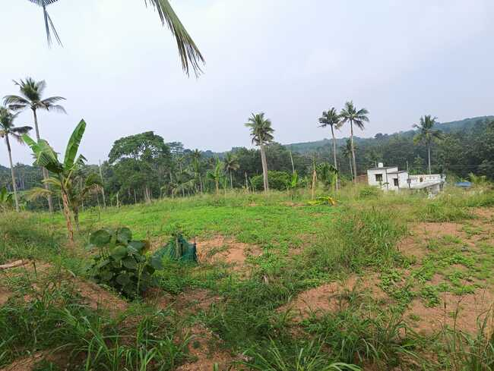

**Assessment of the feasibility of FSTP in Agriculture Farm Anchal, Kollam**

| Date of visit | 29.11.2024 |
| --- | --- |
| Members for Visit | 1. Er Kavitha S Director (LWM) Suchitwa Mission |
| 2. Dr. Biju Joseph, Associate Professor, M.S.Swarninathan Rice Research Station, Moncompu, Alappuzha |

# Table of Contents

Table of Contents 2

1. Introduction 3

2. Site Visit Details 5

2.1 Distance from Nearest Habitation 8

2.2 Proximity to Water Bodies 9

2.3 Land Area and Terrain Inclination 10

2.4 Accessibility and Transportation Feasibility 10

2.5. Availability of Utilities (Power & Water Supply) 11

2.6 Agricultural utility of the land 12

3. Observation and Recommendation 12

# Introduction

Kerala has achieved Open Defecation Free (ODF) status, ensuring that all households have access to toilets. However, the absence of Faecal Sludge Treatment Plants (FSTPs) poses a significant sanitation challenge. With a high water table and abundant water bodies, improper disposal of faecal sludge leads to groundwater and surface water contamination, increasing the risk of waterborne diseases. To safeguard public health and environmental sustainability, it is crucial to establish FSTPs across the state, ensuring safe collection, treatment, and disposal of faecal sludge while promoting resource recovery and sustainable sanitation practices.

The Ministry of Environment, Forest and Climate Change (MoEF&CC) of India published the draft Liquid Waste Management (LWM) Rules, 2024 on October 7, 2024. These rules are scheduled to come into effect on October 1, 2025, providing a transition period for stakeholders to comply with the new regulations. In the draft Liquid Waste Management Rules, 2024, in **Chapter V: General Obligations for Sludge/Faecal Sludge Handling Entities.** Specifically, Section 5, Subsection (5) states: "*(5) Promote use treated sludge/ faecal sludge as soil conditioner or organic manure where applicable, ensuring it meets the quality standards for agricultural use as specified by the Ministry of Agriculture and Farmers Welfare and other regulatory bodies."* Also the responsibilities of the Department of Agriculture and Farmers Welfare are outlined in Chapter VII, Rule 4. In this, the Agriculture Department is tasked with the responsibility for facilitating the development of standards under the Fertilizer Control Order, enabling the use of sludge and faecal sludge as organic manure or soil conditioners. Additionally, the department is tasked with preparing guidelines for the proper application of these materials on agricultural land, ensuring they contribute to soil health without causing environmental harm.

Agriculture farms, being Government-owned, provide an ideal location for these facilities as the treated water and sludge produced as byproducts can be beneficially reused in farming, reducing the demand for freshwater irrigation and enhancing soil fertility with nutrient-rich biosolids. This approach promotes a circular economy in wastewater management, minimizes environmental pollution, and supports sustainable agriculture.

Hon Chief Minister of Kerala has convened a meeting on 03.09.2024, 03.30 pm with Ministers of agriculture and LSG to take a decision to alot the feasible land for setting up FSTP. It was decided to find the feasibility of setting FSTP in PSUs under the ownership of the Agriculture Department. A five member committee was constituted as per GO(Rt) 868/2024/AGRI dated 18/09/2024 to locate a parcel of land of one acre for the establishment of a pilot FSTP of suitable capacity.

Members of the committee are the following.

| Sl No | Name and Designation | Type |
| --- | --- | --- |
| 1 | Shri. Prasanth Nair.N, IAS, Special Secretary to Government (Agriculture) | Convenor |
| 2 | Smt. Anupama. T.V., IAS, Special Secretary to Government (LSGD). | Member |
| 3 | Smt.Kavitha S, Director, Liquid Waste Management (LWM) of Suchithwa Mission. | Member |
| 4 | Dr. Biju Joseph, Associate Professor, M.S. Swaminathan Rice Research Station, Moncompu, Alappuzha. | Member |
| 5 | Dr.K.P.Sudheer, Professor & Head, Department of Agricultural Engineering, College of Agriculture, Velanikkara, Thrissur. | Member |

This committee conducted its first meeting on 24.10.2024, 11:15 a.m and decided to find land under the agricultural department in Kollam district. Based on this, a site visit was conducted in the Agriculture Farm situated in Anchal on 29.11.2024. Smt.Kavitha S, Director, Liquid Waste Management (LWM) of Suchitwa Mission and Dr. Biju Joseph, Associate Professor, M.S. Swaminathan Rice Research Station, Moncompu, Alappuzha, Er. Rachel Thomas, Environmental Engineer, Kollam District Office, KSPCB along with District Suchitwa Mission conducted the visit.

The District Suchitwa Mission had previously informed the District Agriculture Officer, Kollam about the scheduled visit. However, the Superintendent stated that no official communication had been received from the Agriculture Department regarding the visit. Upon arrival on 29.11.2024, the Superintendent expressed his inability to assist with the site visit due to the absence of formal permission from the Agriculture Department. Following a series of phone calls to the respective department heads, instructions were obtained for allowing the visit to proceed. Subsequently, the team conducted the site inspection within the farm, accompanied by a staff member assigned by the Superintendent.

# Site Visit Details

Kottukkal agricultural farm is located at Ittiva Grama Panchayath in Chadayamangalam block in Kollam District. The farm started functioning in 1971 and has an area of 140.54 ha, of which 125.84 hectares are utilized for scientific cultivation. Major crops cultivated include coconut, cashew, pepper, mango, plantain, pear, rambuttan, tubers, ginger, turmeric passion fruit etc. High quality graft seedlings of coconut, ornamental plants, cashew, pepper, plantain, mango, rambutan, kudampuli etc. are also cultivated.(Source: [www.kissan.kerala.gov.in](http://www.kissan.kerala.gov.in)).

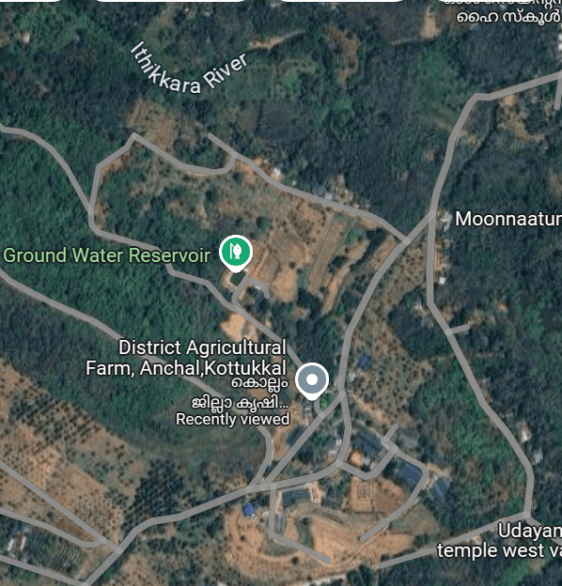

Fig 1 : Agriculture Farm

Upon visit, it is observed that the entire farm area is occupied with different types of agricultural activities. Among this, a site that has separate access was searched. A location where the rambutan saplings were cultivated seems to be suitable. The distance criteria were checked. There is a house and a temple located at the other end of the road. Distance are marked in Fig. 4. During the visit the entire farm could not be visited and interaction with officials of the department of agriculture was also not possible to ascertain the land suitability of different areas of the farm which would have helped to identify a more suitable land for FSTP



Fig 2: Proposed Location

[Location view in google map](https://maps.app.goo.gl/WUe8u6oiXimc5B2x5)

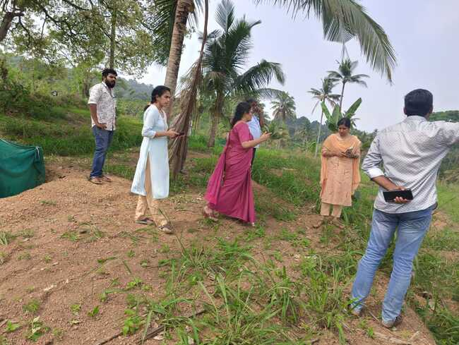

Fig 3: Committee Members conducting Site visit

## 2.1 Distance from Nearest Habitation

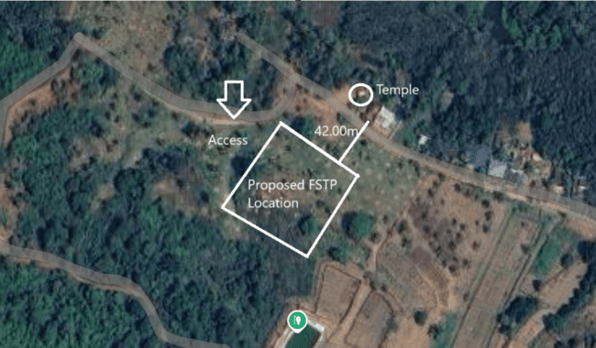

Fig 4: Proposed FSTP Location marked with distances- Satellite View

As per KSPCB guidelines, the FSTP should be located at a distance of 25 logQ, where Q represents the plant capacity in KLD, from the nearest residence to the closest structure of the Treatment Plant. Based on this criterion, the proposed location can be adjusted to ensure a minimum distance of 43 meters from the nearest house, assuming a capacity of 50 KLD. FSTP upto capacity 100 KLD can be constructed by slightly repositioning the designated land further back.

| Sl No | Capacity of Plant | Distance from the nearest habitation |
| --- | --- | --- |
| 1 | 50 KLD | 43.00 m |
| 2 | 70 KLD | 47.00 m |
| 3 | 100 KLD | 50.00 m |

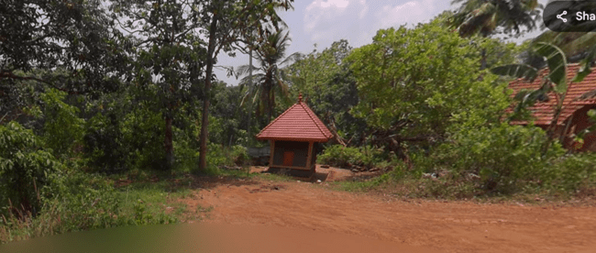

Fig 5 : Small Temple situated to the other side of access Road

## 2.2 Proximity to Water Bodies

The proposed site is located at a distance of approximately 136 m from the nearest river Ithikkara. Minimum distance from the point of discharge of treated sewage to water bodies is also 25 logQ, where Q represents the plant capacity in KLD.

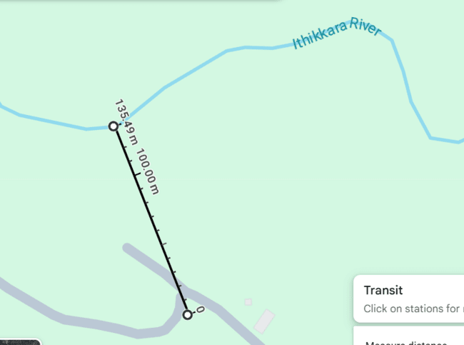

Fig 6: Distance of Nearest water body

## 2.3 Land Area and Terrain Inclination

The land needed to accommodate treatment units, sludge drying beds, and buffer zones. A minimum of 0.5 to 1 acre is required for an FSTP. This land has gentle inclination towards northwest direction which is good to facilitate natural drainage without requiring excessive earthwork or pumping costs

## 2.4 Accessibility and Transportation Feasibility

The site has direct access without entering into farm which helps in the easy transportation of desludging vehicles. The width of the road is 5.00 m.

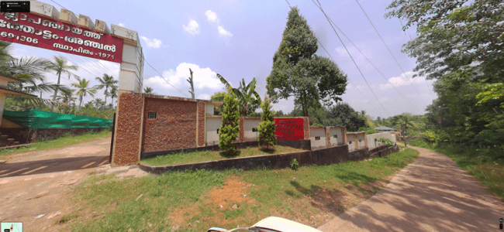

Fig 7: Separate access of 5.0 m to the proposed location

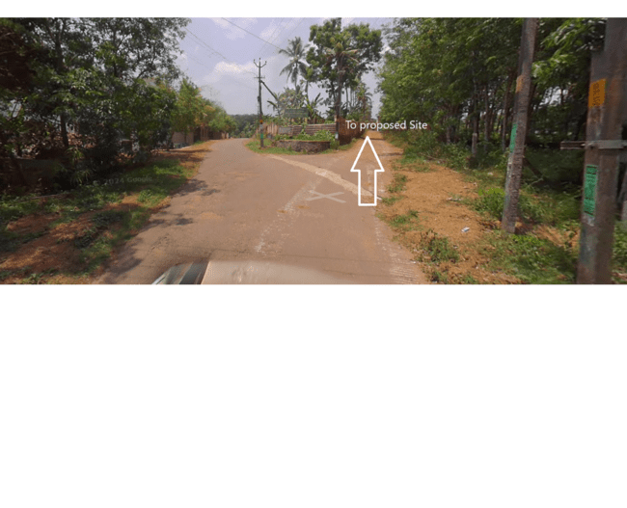

Fig 7: Access from the main road to the proposed location

## 2.5. Availability of Utilities (Power & Water Supply)

The site has access to electricity and water

## 2.6 Agricultural utility of the land

The soil of the site is deep well drained lateritic soil which is of good agricultural value and suitable for most upland crops. Currently 2 year old exotic varieties of rambutan are planted here to be established as mother plant nursery for rambutan graft production and the interspaces are utilized for vegetable seed production which are major activities of the farm.

Selection of the site without considering the land suitability of different areas of the farm will result in loss of valuable agricultural land for the farm. Hence one more visit should be done including the officials of the department of agriculture so that an appropriate land that is not utilized for seed production and horticultural activities can be identified and considered for establishment of FSTP.

# Observation and Recommendation

Based on the available limited information such as the boundary of Farm, the site visit was conducted and this report is prepared.

1. A land of 0.50 acre to 1 Acre can be demarcated for FSTP as of now Rambuttan saplings are presently cultivated with separate access without entering the farm.
2. The proposed land meets the **distance criteria** as per KSPCB guidelines.
3. There is a small temple which is approximately 50 m away from the proposed site
4. Road width of 7.0 m was preferred. But only 5.0 meters is available.
5. The committee would like to conduct a detailed site investigation of the farm in the presence of the officials of the department of agriculture subject to the necessary sanction being obtained.