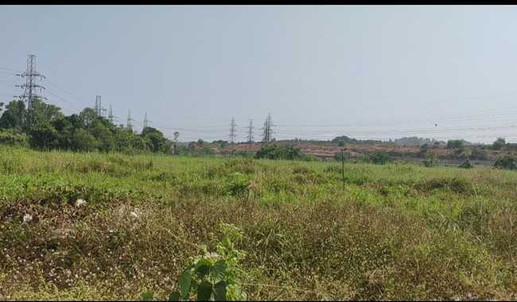

Septage Treatment Plant at

Brahmapuram

Field Inspection Report

07-01-2023

LWM Technical committee, Suchitwa Mission

Table of Contents

**1. Background** **3**

**2. Project Details** **4**

a. Proposed site 4

b. Capacity 5

c. Technology 5

**3. Issues and Observations** **6**

Issues 6

Observations 7

**4. Recommendations.** **9**

# Background

Kochi Urban Agglomeration (UA) consists of Kochi Corporation, nine Municipalities and forty Grama Panchayats of Kerala. The Joint Planning Committee (JPC) of Kochi UA decided to utilize a grant of INR 23.14 Crores received from Central Finance Commission (CFC) for establishing a Septage Treatment Plant (SeTP) for Kochi UA. KMC has been entrusted as the project proponent for this project by the JPC of Kochi UA. KMC has selected M/s ULTRA TECH Environmental Consultancy as the DPR consultant and an inception report was submitted to Suchitwa Mission on 02/03/2022 instead of a Detailed Project Report (DPR). The inception report was reviewed by the Committee twice (i) Review 1 dated on 05/08/2022 and ii) Review 2 (based on the comments in Review 1) dated 16/11/2022. Committee expressed apprehension on the proposed capacity, location and technology. At the meeting, the Chairman of the Health Standing Committee from Kochi Corporation expressed dissatisfaction with the delay in approving the project for which land and funds are available. Considering the genuine interest of the Chairperson and the fact that the report submitted is only an inception report which is normally not submitted and only a DPR is submitted, the Committee expressed their inability to admit the inception report as such as the report is ambiguous and unclear on a number of facts which are required for the Committee to grant consent to the preparation of the DPR. The Committee also felt that it is unlikely that the project could be completed within March 2023 even if the inception report is approved. Hence the Committee suggested that the Local Body may decide to implement the project through the DBOT procedure as per the Government Order (Gov(Ms)No.1058/2022/LSGD dated 28/04/2022), if KMC wants to start the work at the earliest. It will be easy since two agencies (IRTC and CDD Society) have already been accredited by LSGD, and land and funds are readily available. The Committee assured to provide all the technical support required for the procedure. Though the Chairman of the Health Standing Committee and the representatives from the LB agreed to this suggestion, a subsequent meeting was held by the Mayor of Kochi Corporation with the Executive Director of Suchitwa Mission to discuss the matter, in which it was suggested that the Committee members visit the proposed site to understand the nature of the land and the possibility of setting up the plant. Accordingly , the field visit was conducted on 07/01/2023, 11.30 am by the LWM Technical committee.

# Project Details

The SeTP is proposed to be constructed at Brahmapuram, in an area of approximately 3.9 acres of land owned by the biggest beneficiary of Kochi UA, the Kochi Municipal Corporation (KMC).

## Proposed site

The Land identified for the project is owned by KMC at Puthencruz village, Kunnathunadu Taluk, Vadavucode – Puthencruz Grama Panchayath, Ernakulam District, Kerala. The land is approximately 100 m away from the existing 100 KLD SeTP at Brahmapuram

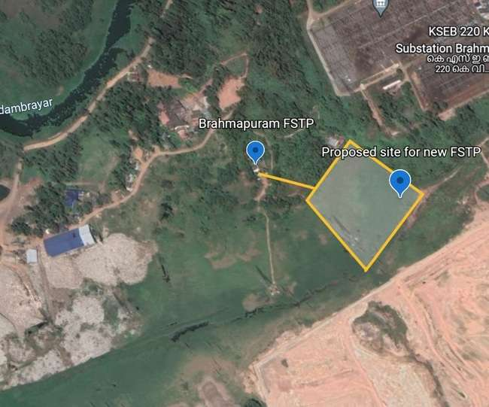

In the Inception report submitted by KMC stated the following.

*“The District Disaster Management Plan (DDMP) of Ernakulam District was referred to assess the susceptibility of the proposed site to natural disasters. Since the site is in the flood plain of Kadambrayar and is water logged and low lying, susceptibility to flood needs utmost attention while planning and designing any facilities at the site. The anticipated risk of natural hazards at the proposed project site is as follows:*

***7.2.1. Flood***

*As per the flood susceptibility map of Ernakulam District shown in Figure 7.3 , it can be observed that the proposed project site falls in flood prone area”*

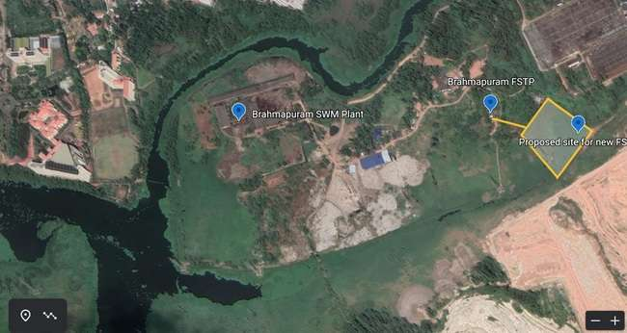

## Capacity

As per the latest inception report the capacity is assessed based on projected population in 2051. The capacity arrived is 1.91 MLD which is based on the projected number of septage trucks in 2051. Hence the capacity is proposed as 2 MLD.

## Technology

The proposed treatment scheme is as follows

Receiving Channel →Bar screen →Vortex grit separator →Equalization Tank →High rate anaerobic filter (UASBR) →Anoxic- Oxic tanks with FeCl3  dosing→Secondary clarifier → Pressure filter→Chlorine Contact Tank → Activated carbon filter → Treated water Tank

**Sludge Management System**

Sludge Collection Tank→Polyelectrolyte dosing →Filter Press → Rotary Kiln incinerator → Wet scrubber → Clean air

↳Ash → KEIL

# Issues and Observations

This section covers the issues and observations by the technical committee members after the site visit to the proposed plant and existing FSTP at Brahmapuram on 07/01/2023.

## Issues

* The proposed capacity is high and the estimated capacity for the Ernakulam district is less than 1 MLD even after considering the future requirement. Proposals for a higher capacity may lead to wastage of financial resources and the taxpayer’s money. The capacity of the plant is to be reworked taking into consideration the proposals that are under process by KWA and LSGs for STPs and FSTPs with funding from different sources.
* Kochi corporation mentioned the willingness of the emptier to operate the truck for more than 20km and this will add burden to lower and middle class households due to high pricing (more distance affects the affordability).
* The road and transportation infrastructure for bringing high capacity of septage from longer distances beyond 20 km on a regular basis will be challenging for all the stakeholders (emptiers, traffic police and treatment plant operators). It would be advisable to get the expert opinion/ comments of a Traffic and Transportation expert on the viability of 800 vehicles plying to and fro from different parts to Brahmapuram to be obtained.
* CPHEEO/Ministry of Housing and Urban Affairs (MoHUA) has not recommended such a high capacity plant with the proposed BFBR technology for a highly populated agglomeration like Kochi.
* Further the performance evaluation of BFBR technology has not been made available in the inception report and hence proceeding with such an unproven technology in such a high capacity plant (and that too which doesn’t exist anywhere in the country) needs to be given a second thought.
* The technical committee is of the opinion that it would be advisable if such a high capacity treatment facility with the proposed technology is taken up as a Design, Build, Operate, and Transfer (DBOT) model.

## **Observations**

The technical committee visited the existing treatment plant and the site for the proposed treatment plant and made the following observations.

1. The objectives of the visit are i) to inspect the functionality of the FSTP as per the comment of the Chief Engineer, Kerala State Pollution Control Board (KSPCB) ii) to understand the current status of the existing faecal sludge treatment facility of the corporation in terms of its operability, record maintenance and accountability mechanisms.

The following observations have been made.

1. There data on faecal sludge inflow, quantity & quality of faecal sludge received, details of truck operators emptied in the FSTP, the quantity of disinfectant chemicals (hypochlorite) usage and the total quantity of septage treated in the week or month are not recorded.
2. Visual observations indicated that the sludge drying beds of the treatment unit of the FSTP have not been put into use during recent months.

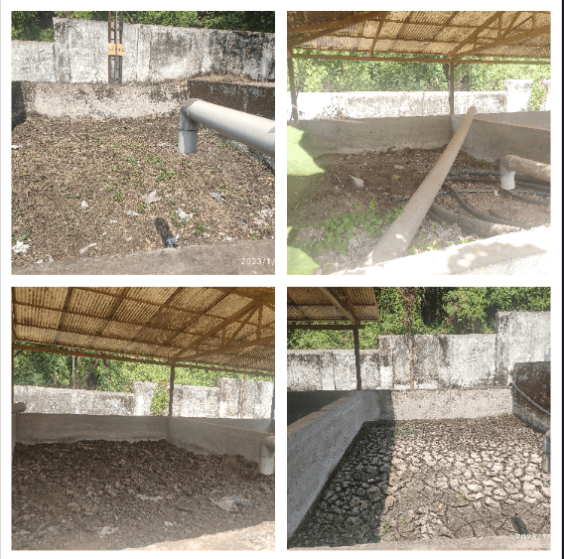

c) The leachate from the existing MSW dumping yard is being treated in the FSTP.

d) It is noticed that the recirculation system for UASB is corroded and unusable.

e) The flaring system for methane is not working and the collection chamber of methane is totally damaged due to aggressive corrosion.

f) It was ominous to witness untreated faecal sludge getting deposited outside the plant premises in a low lying area.

g) There is no closed circuit television installed in the plant.

h) The existing FSTP in Brahmapuram is not used in its potential and no GPS tracking facility of the vehicles is available to ensure that sufficient loads are reaching the plant.

i) The use of safety equipment or PPEs is not evident among the operators in the treatment plant.

j) PAC and hypochlorite solutions were unavailable in the existing treatment unit.

2) The proposed site was examined to understand the feasibility of implementation of the new FSTP.

1. The proposed site for FSTP was found to have a narrow passage and new road infrastructure is needed to access the site.
2. The existing site has only two lane roads from the city limit and several road blocks due to vehicle traffic were observed.
3. The site is low lying and water logged, with thick weed cover and abutting the Kadambrayar.
4. ~~T~~The septage was dumped in the upstream side of the proposed site and the site will receive any wastewater discharges in the upstream side.
5. The site looked like a wetland.
6. .Kerala State Electricity Board (KSEB) electric lines and power grid were positioned near the site.

# Recommendations.

Based on the site visit and subsequent interactions with the Chairperson of Health Standing Committee, the Environmental Engineer and the Executive Engineer of KMC, the technical committee is of the opinion that necessary treatment facility to fill the gap of liquid waste treatment in the District to be set up at all feasible sites by utilizing all available resources. Considering the interest of the Corporation to set up a plant at a feasible site away from the general population, the Committee decided that the Septage Treatment Plant may be established in the proposed land subject to the following.

1. The existing and projected septage/faecal sludge generation may be estimated based on IS 2470 and the existing and proposed facilities for separate or co-treatment of septage/faecal sludge in the District may be considered and accounted for arriving at the capacity of the new SeTP/FSTP proposed. The capacity of the plant may be estimated only based on faecal sludge/septage generated and not based on the number of tankers plying in the District as most of the tankers are carrying greywater from Hotels and establishments which is not to be treated in an FSTP/SeTP. As the co-treatment is more sustainable than the stand alone treatment, the master plan of the sewerage System to be collected from the Kerala water authority and the septage load is shared with respective Sewage Treatment Plant wherever possible based on a combined discussion in between Kochi Corporation With Kerala Water Authority. This type of strategic decisions will reduce the complexity of operation and maintenance in addition to a drastic reduction of the environmental footprint of the whole system. 1(a) Site suitability based on the siting norms of KSPCB shall be compiled for various units of the plant.
2. The existing FSTPs at Brahmapuram and Willingdon island must be used to their fullest potential so as to ensure that only the required load is treated in the newly proposed plant.
3. As per the Inception Report, “the site is a wetland and is falling under the floodplain of Kadambrayar''. The Committee couldnt ascertain the impact of possible floods on the proposed plant during the field visit. However it is seen that the tower of KSEB carrying HT lines is supported on a foundation which is about 3 m above GL which indicates the necessity of elevated construction for the new plant. Also since the inception report clearly mentions such an impact due to floods, clarification in this regard from the Irrigation Department and Disaster Management Authority may be obtained regarding the flood level and necessary resilience may be inbuilt in the design of new plant.
4. The site being a wetland, conversion may be done with Government Sanction for the construction.
5. The Capex and Opex sharing of the participatory local bodies may be finalised and MoUs may be drafted between KMC and the other local bodies.
6. Kochi corporation should plan the treatment plant in a futuristic manner to avoid any financial or livelihood losses to any stakeholder involved in the service delivery. The services shall be win-win for all the stakeholders in the corporation.
7. Kochi corporation shall ensure the safety of sanitation workers working in the treatment plant and shall adopt the standard operating procedures issued by the MoHUA.
8. Real time Effluent Monitoring System shall be implemented so that the quality can be verified through KSPCB portal.
9. In the wake of NGT order to show progress in LWM activities within a short period of 6 months, it will be ideal if the TMC executes the work through DBOT mode or through accredited agencies with a construction time limit of four months. The present system of inception report, approval, DPR preparation, Technical Sanction and repeated tender for implementation can be avoided by taking projects in DBOT mode.

| Sl. No. | Name & Designation | | Signature |
| --- | --- | --- | --- |
| 1 | Dr. K.B. Radhakrishnan,  Prof.& Head, Dept of  Biotechnology & Biochemical  Engineering, Sree Chitra  Thirunal College of  Engineering, Pappanamcode  Thiruvananthapuram. | |  |
| 2. | Smt. Sreekala. S, Chief  Environmental Engineer,  Trivandrum Regional Office,  Kerala State Pollution  Control Board. | |  |
| 3. | Sri. Narayanan Namboothiri,  Deputy Chief Engineer  Kerala Water Authority  Thiruvananthapuram. | |  |
| 4. | Sri. Praveen K.S,  Director (Liquid Waste Management)  Suchitwa Mission. | |  |
| 5. | Sri. Renju R Pillai  Senior Consultant (Design)  Suchitwa Mission | |  |
| 6. | Smt. Resmi P.S,  Program Officer (Training) & LWM Expert (i/c)  Suchitwa Mission. | |  |
| 7. | Sri. Vipin. S,  Sanitation Expert  Suchitwa Mission. | |  |
| 8. | Sri. Sheik Mohammed Shibl  Water Specialist, WASH Institute, UNICEF | |  |