**Kerala State Plan for Faecal Sludge and Septage Management (FSSM)**

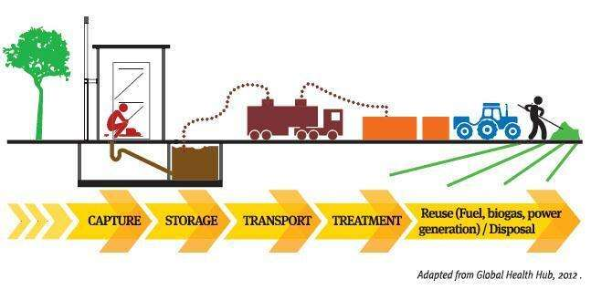

**Accelerating towards Open Defecation Free + (ODF+)**

**Submitted by**

**Suchitwa Mission**

**Kerala**

**August 2023**

# Table of Contents

Table of Contents 2

1. Introduction 3

2. Current Scenario 3

3. Issues and solutions 3

4. Cluster-based approach 3

5. Current plan for FSSM implementation 23

6. Way forward 40

6.1 Institutional Strengthening 40

a. Strengthening of LSGI: 40

b. District Water and Sanitation Committee 40

c. Empanelment of agencies for FSTP technology service providers 40

d. Capacity Building of LSGI Engineers 40

e. Exposure visit to best practice cities 41

f. Safety practices during desludging operations for Sanitation workers 41

6.2 Information, Education and Communication (IEC) activities 41

a. Malambhootham Campaign 41

6.3 Revenue model and Financing mechanism for FSSM 42

7. Current status in the FSSM Implementation 42

7.1 Ongoing Projects 43

7.2 DPC Approved / Proposed Projects 43

7.3 Mobile FSTPs 45

7.4 FSTP Projects to be approved 46

# Introduction

Kerala achieved Open Defecation Free (ODF) status in the year 2016, but the state is faced with a second-generation challenge of faecal contamination of water bodies. The water sources of the state are contaminated by the pollutants entering the water bodies and the environment through indiscriminate disposal of septage and lack of treatment infrastructure resulting in public and environmental health risks. The state is predominantly served by the onsite sanitation systems (OSS) and the networked sanitation coverage is minimal in the state. There is increasing attention to safe sanitation and FSSM in the state for achieving SBM 2.0 goals and the state is keen on establishing an ecosystem to improve public and environmental health.

# Current Scenario

Presently, faecal waste is treated in Thiruvananthapuram through co-treatment at Sewage Treatment Plant (STP), Kochi through two Faecal Sludge Treatment Plant (FSTP)s, Kalpetta and Wayanad through FSTPs. Roughly less than 10% of faecal sludge generated is being treated or safely managed in the state. The lack of infrastructure causes indiscriminate disposal of wastewater to the water bodies and the campaign “Thelineer Ozukhum Navakeralam” determined that the state’s majority of water bodies are contaminated with faecal matter. It is the need of the hour to establish sufficient treatment infrastructure for treatment of wastewater.

# Issues and solutions

Kerala is faced with a series of issues for implementation of sewered sanitation solutions in its towns and villages due to diverse geography, public protests, unavailability of land and high road cutting costs. To tackle this situation, the state government conducted a feasibility study in the 14 districts of Kerala to establish faecal sludge treatment units in unused quarry sites and deteriorated lands where the land issue and public unrest is minimal through an issuance of a government order G.O.(Rt) No.2558/2022/LSGD on 21/10/2022. Based on the government order District level inspection committee for checking the feasibility of proposal for setting up Faecal sludge Treatment Plants(FSTPs) in degraded land. 88 sites were identified through the study. Altogether 88 sites were identified for the FSTP implementation. This includes a total of 36 quarries which include 10 government quarries and 26 private quarries, 6 Revenue lands, 31 LSGI lands, 9 lands owned by Other depts, and 6 private lands were included in the cluster formation.

# Cluster-based approach

It was suggested to implement a cluster approach for establishing faecal sludge treatment units and utilising them in an efficient manner. Local Self Government Institutions (LSGI) have been clustered around the proposed faecal sludge treatment unit within a radius of 15km. Suchitwa Mission the Technical Support Group of LSG department conducted a capacity building program to the district technical coordinators to form clusters for establishing faecal sludge treatment units in their respective districts based on the situational assessment conducted. Each site will be one cluster catering the needs of the Grama Panchayat, Municipality and Corporations in the radius of the cluster.

Table 1:Number of Clusters in each type of land

| **Sl. No** | **District** | **Quarry** | | **Public** | | | **Private** | **Total** |
| --- | --- | --- | --- | --- | --- | --- | --- | --- |
| **Government Quarry** | **Private Quarry** | **Revenue land** | **LSGI Land** | **Other Dept. Land** | **Private Land** |
| 1 | Thiruvananthapuram | 1 | 2 | 1 | 1 | 2 | 1 | 8 |
| 2 | Kollam | 1 | 1 | 1 | 0 | 0 | 0 | 3 |
| 3 | Pathanamthitta | 3 | 2 | 0 | 0 | 0 | 0 | 5 |
| 4 | Alappuzha | 0 | 0 | 0 | 3 | 1 | 1 | 5 |
| 5 | Kottayam | 0 | 2 | 0 | 1 | 2 | 0 | 5 |
| 6 | Idukki | 3 | 1 | 0 | 1 | 0 | 1 | 6 |
| 7 | Ernakulam | 0 | 4 | 0 | 4 | 1 | 1 | 10 |
| 8 | Thrissur | 0 | 3 | 1 | 3 | 0 | 0 | 7 |
| 9 | Palakkad | 1 | 3 | 2 | 3 | 1 | 0 | 10 |
| 10 | Malappuram | 0 | 3 | 0 | 3 | 1 | 0 | 7 |
| 11 | Wayanad | 1 | 1 | 0 | 3 | 0 | 0 | 5 |
| 12 | Kozhikode | 0 | 1 | 0 | 4 | 0 | 0 | 5 |
| 13 | Kannur | 0 | 3 | 0 | 2 | 1 | 0 | 6 |
| 14 | Kasargod | 0 | 0 | 1 | 3 | 0 | 2 | 6 |
|  | **Total** | **10** | **26** | **6** | **31** | **9** | **6** | **88** |

The list of sites and clusters above mentioned are based on a preliminary feasibility assessment and incase of public unrest alternate sites would be identified.

1. **Thiruvananthapuram**

Thiruvananthapuram district is the southernmost district, which consists of 73 Grama Panchayath, 4 Municipalities and 1 Corporation. There are 8 clusters identified for the district. The details of the FSTP cluster and the GIS based clustering is shown in the Table and the Figure below.

**Table 2: Identified sites in Thiruvananthapuram District**

| **Sl. No** | **Proposed site location** | **Area of land in Cents** | **Capacity**  **(in KLD)** | **Local bodies covered (Number)** | | | |
| --- | --- | --- | --- | --- | --- | --- | --- |
| **GP** | **Municipality** | **Corporation** | **Total** |
| 1 | Nettukaltheri, Kallikadu | 100 | 56 | 9 | 0 | 0 | 9 |
| 2 | Vamanapuram. | 100 | 24 | 4 | 0 | 0 | 4 |
| 3 | Karavaram. | 217 | 85 | 14 | 1 | 0 | 15 |
| 4 | Nellisery,Vellarada | 250 | 73 | 8 | 1 | 0 | 9 |
| 5 | Pallipuram,Azhoor | 400 | 72 | 11 | 1 | 0 | 12 |
| 6 | Irinjayam,Anad | 261 | 91 | 12 | 1 | 0 | 13 |
| 7 | Muttathara -TVM | - | 250* | 5 | 0 | 0 | 5 |
| 8 | Athiyannur. | 100 | 38 | 7 | 0 | 0 | 7 |
|  |  | Total | 689 | 70 | 4 | 0 | 74 |

**\*** *This is an existing STP of capacity 107 MLD and having cotreatment of 250 KLD. The surrounding GPs can use this facility for septage treatment and the plan is being processed.*

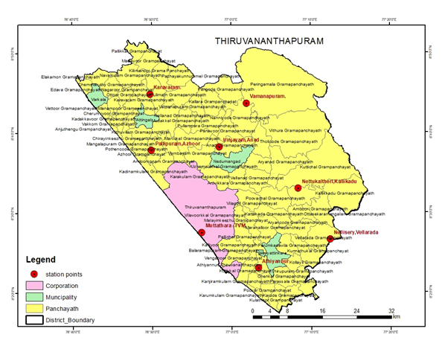

**Figure 1. FSTP site locations in Thiruvananthapuram District**

1. **Kollam**

Kollam district consists of 68 Gramapanchayath, 4 Municipalities and 1 corporation. 3 clusters were identified in the district and the details are shown below

**Table 3: Identified sites in Kollam District**

| Sl. No | Proposed site location | Area of land in Cents | Capacity  (in KLD) | Local bodies covered (Number) | | | |
| --- | --- | --- | --- | --- | --- | --- | --- |
| GP | Municipality | Corporation | Total |
| 1 | Kattamala, Kulapara Pattazhy | 108 | 120 | 10 | 0 | 0 | 10 |
| 2 | Kudavathoor, Veliyam | 12500 | 90 | 13 | 1 | 0 | 14 |
| 3 | Puthiyadom , Ummannoor | 140 | 90 | 10 | 0 | 0 | 10 |
|  |  | Total | 300 | 33 | 1 | 0 | 34 |

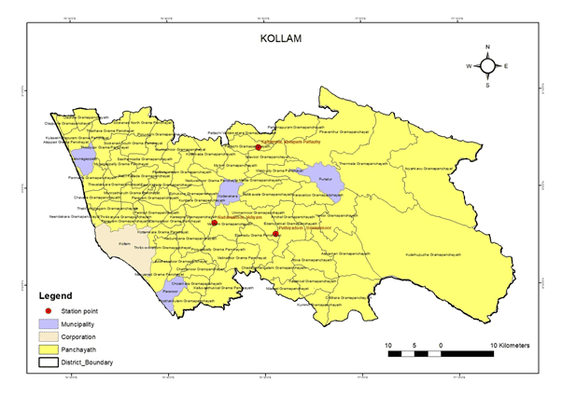

**Figure 2. FSTP site locations in Kollam District**

1. **Pathanamthitta**

Pathanamthitta district is the landlocked district consisting 53 Gramapanchayath and 4 Municipalities. As per the GIS analysis, 100% coverage of FSTP was achieved by clustering. The details of 5 clusters identified are shown below.

**Table 4: Identified sites in Pathanamthitta District**

| **Sl. No** | **Proposed site location** | **Area of land in Cents** | **Capacity**  **(in KLD)** | **Local bodies covered (Number)** | | | |
| --- | --- | --- | --- | --- | --- | --- | --- |
| **GP** | **Municipality** | **Corporation** | **Total** |
| 1 | Koodal. | 7990 | 38 | 6 | 0 | 0 | 6 |
| 2 | Erath. | 131.47 | 52 | 6 | 1 | 0 | 7 |
| 3 | Pandalam. | 203.3 | 40 | 9 | 2 | 0 | 11 |
| 4 | Vadasserikkara. | 506.7 | 57 | 13 | 0 | 0 | 13 |
| 5 | Ezhumattoor. | 3700 | 99 | 19 | 1 | 0 | 20 |
|  |  | Total | 286 | 53 | 4 | 0 | 57 |

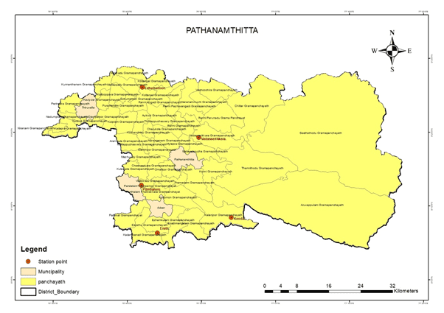

**Figure 3. FSTP site locations in Pathanamthitta District**

1. **Alappuzha**

Alappuzha district consists of 72 grama panchayath 6 Municipalities. Based on the clustering district was able to cover 62 LSGIs. Details of clustering are shown below.

**Table 5: Identified sites in Alappuzha District**

| **Sl. No** | **Proposed site location** | **Area of land in Cents** | **Capacity**  **(in KLD)** | **Local bodies covered (Number)** | | | |
| --- | --- | --- | --- | --- | --- | --- | --- |
| **GP** | **Municipality** | **Corporation** | **Total** |
| 1 | Palamel | 100 | 50 | 9 | 0 | 0 | 9 |
| 2 | Mavelikkara Thekkekkara - Kurathikad | 50 | 70 | 10 | 1 | 0 | 11 |
| 3 | Cherthala - Anatharaveli | 50 | 250* | 14 | 1 | 0 | 15 |
| 4 | Aryad - Charaparambu | 50 | 50 | 10 | 1 | 0 | 11 |
| 5 | Karthikapalli- Mahadevikadu | 85 | 85 | 13 | 2 | 0 | 15 |
|  |  | Total | 505 | 56 | 5 | 0 | 61 |

* *This is an ongoing project under IMPACT.*

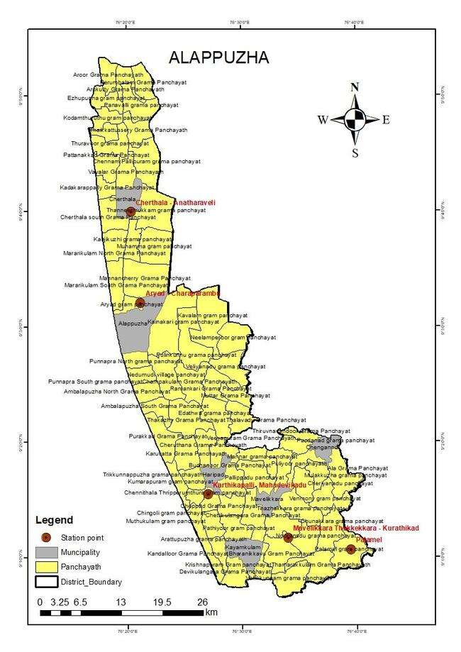

**Figure 4. FSTP site locations in Alappuzha District**

1. **Kottayam**

Kottayam district consists of 71 Gramapanchayath & 6 Muncipalities. As per the FSM plan, the district has covered 100% of the district with 5 clusters of FSTP. The details of clustering are shown below.

**Table 6: Identified sites in Kottayam District**

| Sl. No | Proposed site location | Area of land in Cents | Capacity  (in KLD) | Local bodies covered (Number) | | | |
| --- | --- | --- | --- | --- | --- | --- | --- |
| GP | Municipality | Corporation | Total |
| 1 | Medical College, Kottayam | 300 | 89 | 12 | 1 | 0 | 13 |
| 2 | HNL Compound Velloor | 200 | 67 | 11 | 1 | 0 | 12 |
| 3 | Erumeli. | 250 | 113 | 19 | 1 | 0 | 20 |
| 4 | Ramapuram. | 191 | 60 | 13 | 1 | 0 | 14 |
| 5 | Kottayam. | 325 | 162 | 16 | 2 | 0 | 18 |
|  |  | Total | 491 | 71 | 6 | 0 | 77 |

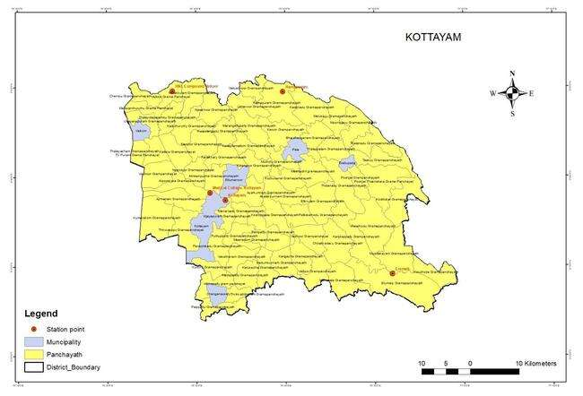

**Figure 5. FSTP site locations in Kottayam District**

1. **Idukki**

Idukki district consist of 52 Gramapanchayath & 2 Muncipalities. With 6 clusters, Idukki district also was able to cover 100%. The details of Cluster are shown below.

**Table 7: Identified sites in Idukki District**

| Sl. No | Proposed site location | Area of land in Cents | Capacity  (in KLD) | Local bodies covered (Number) | | | |
| --- | --- | --- | --- | --- | --- | --- | --- |
| GP | Municipality | Corporation | Total |
| 1 | Edavetty. | 1843.169 | 81 | 8 | 1 | 0 | 9 |
| 2 | Kattappana. | 245.0224 | 78 | 11 | 1 | 0 | 12 |
| 3 | Pallivasal. | 68 | 34 | 8 | 0 | 0 | 8 |
| 4 | Mariyapuram. | 100 | 72 | 13 | 0 | 0 | 13 |
| 5 | Kanthallor | 50 | 14 | 5 | 0 | 0 | 5 |
| 6 | Munnar | 50 | 25 | 7 | 0 | 0 | 7 |
|  |  | Total | 304 | 52 | 2 | 0 | 54 |

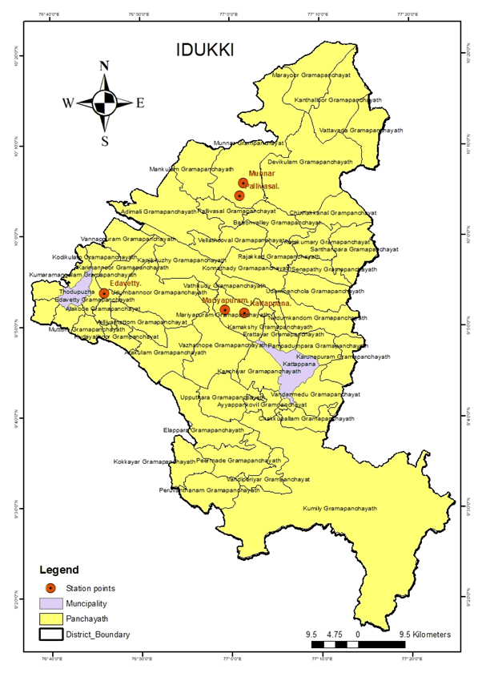

**Figure 6. FSTP site locations in Idukki District**

1. **Ernakulam**

Ernakulam district consists of 82 gramapanchayath, 13 Muncipalities and 1 corporation. With the identified 10 cluster, Ernakulam district was also able to cover 100% for the septage treatment. The details of the clusters are shown below.

**Table 8: Identified sites in Ernakulam District**

| Sl. No | Proposed site location | Area of land in Cents | Capacity  (in KLD) | Local bodies covered (Number) | | | |
| --- | --- | --- | --- | --- | --- | --- | --- |
| GP | Municipality | Corporation | Total |
| 1 | Kalloorkkad. | 480 | 90 | 13 | 2 | 0 | 15 |
| 2 | Pambakkuda. | 1134 | 115 | 11 | 2 | 0 | 13 |
| 3 | Paipra. | 100 | 50 | 13 | 1 | 0 | 14 |
| 4 | Mookkannoor. | 108 | 70 | 10 | 1 | 0 | 11 |
| 5 | Elamkulam. | 100 | 250 | 18 | 3 | 1 | 22 |
| 6 | Ayyankuzhi. | 250 | 50 | 6 |  | 0 | 6 |
| 7 | Vedimara. | 60 | 30 | 8 | 1 | 0 | 9 |
| 8 | Periyar Valley (aluva) | 80 | 20 | 2 | 1 | 0 | 3 |
| 9 | Kalamasseri Dumping Yard | 80 | 20 | 0 | 1 | 0 | 1 |
| 10 | Kottakkunnu. | 60 | 10 | 1 | 1 | 0 | 2 |
|  |  | Total | 705 | 82 | 13 | 1 | 96 |

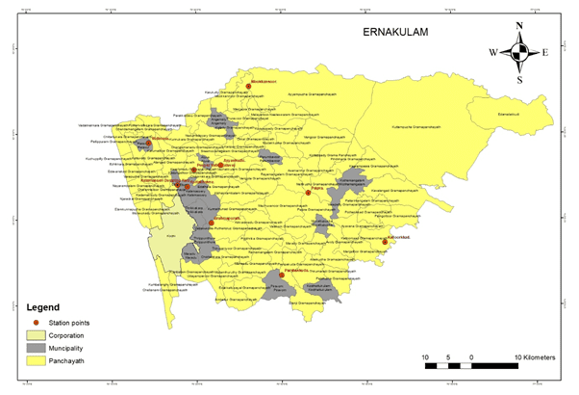

**Figure 7. FSTP site locations in Ernakulam District**

1. **Thrissur**

Thrissur district consists of 86 Gramapanchayath, 7 Municipalities and 1 Corporation. The details of the 7 clusters are shown below.

**Table 9: Identified sites in Thrissur District**

| Sl. No | Proposed site location | Area of land in Cents | Capacity  (in KLD) | Local bodies covered (Number) | | | |
| --- | --- | --- | --- | --- | --- | --- | --- |
| GP | Municipality | Corporation | Total |
| 1 | Meppadam | 50 | 10 | 2 | 0 | 0 | 2 |
| 2 | Vazhakode | 500 | 50 | 1 | 1 | 0 | 2 |
| 3 | Venginissery | 50 | 10 | 3 | 0 | 0 | 3 |
| 4 | Cherussery | 50 | 50 | 2 | 0 | 1 | 3 |
| 5 | Inchakund | 50 | 50 | 5 | 0 | 0 | 5 |
| 6 | Venganellur | 100 | 100 | 7 | 0 | 0 | 7 |
| 7 | Chelakkara Farm | 11200 | 120 | 11 | 1 | 0 | 12 |
|  |  | Total | 390 | 31 | 2 | 1 | 34 |

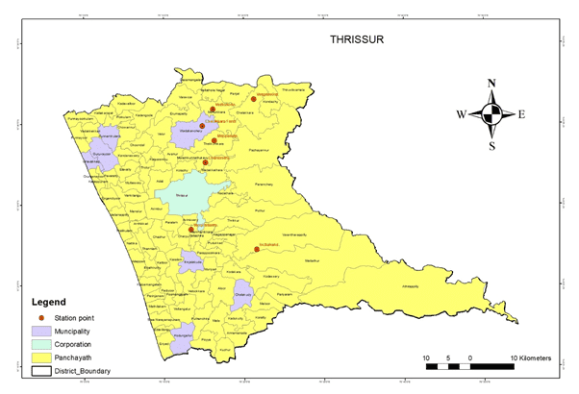

**Figure 8. FSTP site locations in Thrissur District**

1. **Palakkad**

Palakkad district consists of 88 Gramapanchayath, & 7 Municipalities. 10 clusters were identified among the district. The details of the cluster are shown below.

**Table 10: Identified sites in Palakkad District**

| Sl. No | Proposed site location | Area of land in Cents | Capacity  (in KLD) | Local bodies covered (Number) | | | |
| --- | --- | --- | --- | --- | --- | --- | --- |
| GP | Municipality | Corporation | Total |
| 1 | Yakkara | 70 | 100 | 9 | 0 | 0 | 9 |
| 2 | Palakkad Municipality 2 | 180 | 83 | 5 | 1 | 0 | 6 |
| 3 | Attapady. | 75 | 29 | 4 | 0 | 0 | 4 |
| 4 | Muthalamada. | 200 | 96 | 12 | 1 | 0 | 13 |
| 5 | Shornur. | 100 | 44 | 4 | 1 | 0 | 5 |
| 6 | Ottapalam. | 200 | 90 | 9 | 2 | 0 | 11 |
| 7 | Karakurissi. | 200 | 95 | 9 | 1 | 0 | 10 |
| 8 | Ayiloor. | 425 | 82 | 10 | 0 | 0 | 10 |
| 9 | Kuthanoor. | 200 | 80 | 11 | 0 | 0 | 11 |
| 10 | Thrithala. | 1000 | 135 | 15 | 1 | 0 | 16 |
|  |  | Total | 834 | 88 | 7 | 0 | 95 |

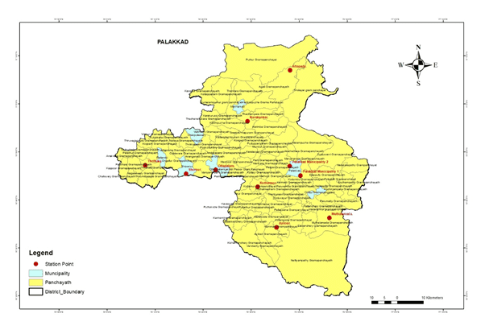

**Figure 9. FSTP site locations in Palakkad District**

1. **Malappuram**

Malapuram district consist of 94 gramapanchayath, 12 Municipalities. With 7 cluster,s Malappuram district achieved 100% LSGI coverage for the septage treatment. The details of the cluster are shown below.

**Table 11: Identified sites in Malappuram District**

| Sl. No | Proposed site location | Area of land in Cents | Capacity  (in KLD) | Local bodies covered (Number) | | | |
| --- | --- | --- | --- | --- | --- | --- | --- |
| GP | Municipality | Corporation | Total |
| 1 | Nilambur BP Plot | 450 | 125 | 13 | 1 | 0 | 14 |
| 2 | Perinthalmanna. | 550 | 145 | 13 | 1 | 0 | 14 |
| 3 | Tavanur Central Jail | 200 | 100 | 10 | 2 | 0 | 12 |
| 4 | Tirur Ground | 200 | 210 | 19 | 3 | 0 | 22 |
| 5 | Cherukavu GP | 50 | 140 | 11 | 0 | 0 | 11 |
| 6 | Kondotty. | 50 | 195 | 16 | 3 | 0 | 19 |
| 7 | Manjeri . | 50 | 275 | 12 | 2 | 0 | 14 |
|  |  | Total | 1190 | 94 | 12 | 0 | 106 |

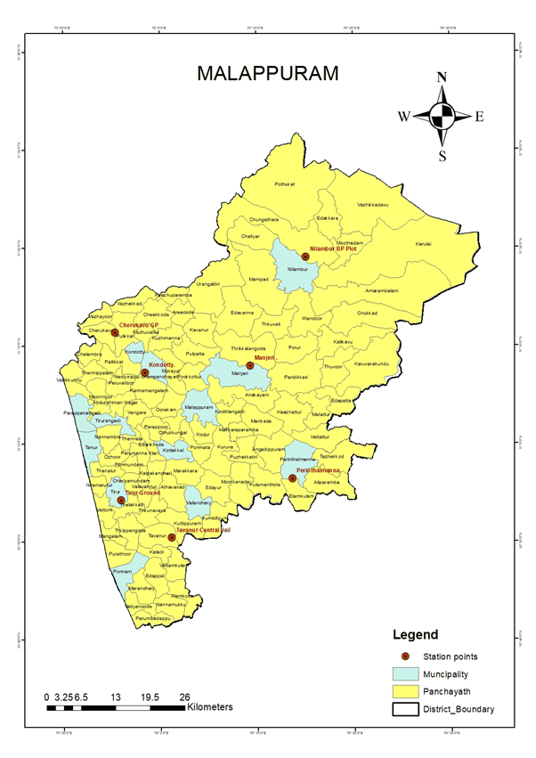

**Figure 10. FSTP site locations in Malappuram District**

1. **Wayanad**

Wayanad district consists of 23 gramapanchayath and 3 Municipalities. The details of 5 clusters identified are shown below.

**Table 12: Identified sites in Wayanad District**

| Sl. No | Proposed site location | Area of land in Cents | Capacity  (in KLD) | Local bodies covered (Number) | | | |
| --- | --- | --- | --- | --- | --- | --- | --- |
| GP | Municipality | Corporation | Total |
| 1 | Aarattupura - Ambalavayal | 55 | 55 | 4 | 1 | 0 | 5 |
| 2 | Vellaramkunnu - Kalpetta | 800 | 35 | 3 | 1 | 0 | 4 |
| 3 | Pulppalli. | 75 | 35 | 4 | 0 | 0 | 4 |
| 4 | Vellamunda. | 150 | 65 | 6 | 1 | 0 | 7 |
| 5 | Vengappalli. | 50 | 20 | 5 | 0 | 0 | 5 |
|  |  | Total | 210 | 22 | 3 | 0 | 25 |

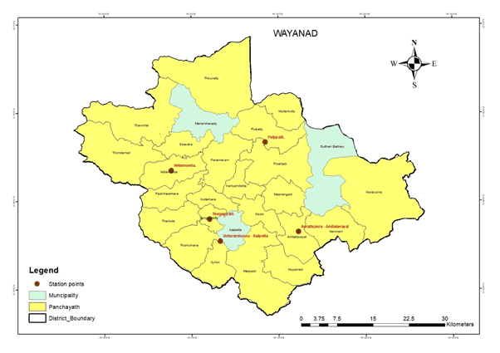

**Figure 11. FSTP site locations in Wayanad District**

1. **Kozhikode**

Kozhikode district consists of 70 Gramapanchayath, 7 Municipalities and 1 Corporation. With 5 clusters, the district has covered 100% LSGI Coverage. The details of clusters are shown below.

**Table 13: Identified sites in Kozhikode District**

| Sl. No | Proposed site location | Area of land in Cents | Capacity  (in KLD) | Local bodies covered (Number) | | | |
| --- | --- | --- | --- | --- | --- | --- | --- |
| GP | Municipality | Corporation | Total |
| 1 | Thamarassery. | 400 | 168 | 18 | 1 | 0 | 19 |
| 2 | Kumaranellor. | 400 | 74 | 7 | 1 | 0 | 8 |
| 3 | Meppayur GP | 125 | 253 | 28 | 3 | 0 | 31 |
| 4 | Kozhikode Corporation | 200 | 235 | 4 | 2 | 1 | 7 |
| 5 | Chekyad. | 50 | 89 | 13 | 0 | 0 | 13 |
|  |  | Total | 819 | 70 | 7 | 1 | 78 |

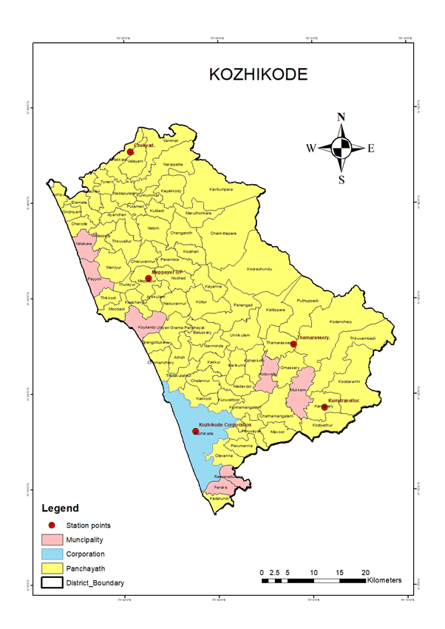

**Figure 12. FSTP site locations in Kozhikode District**

1. **Kannur**

Kannur district consists of 71 Gramapanchayath, 9 Municipalities and 1 Corporation. The 100% coverage of LSGI was done with identified 6 clusters. The details are shown below

**Table 14: Identified sites in Kannur District**

| Sl. No | Proposed site location | Area of land in Cents | Capacity  (in KLD) | Local bodies covered (Number) | | | |
| --- | --- | --- | --- | --- | --- | --- | --- |
| GP | Municipality | Corporation | Total |
| 1 | Pariyaram Medical College | 50 | 164 | 16 | 3 | 0 | 19 |
| 2 | Kuttiattoor. | 70 | 226 | 18 | 1 | 1 | 20 |
| 3 | Kambalari- Sreekandapuram. | 100 | 87 | 10 | 1 | 0 | 11 |
| 4 | Ayyankunnu. | 500 | 68 | 9 | 1 | 0 | 10 |
| 5 | Valliyai. | 100 | 100 | 10 | 1 | 0 | 11 |
| 6 | Pettipaalam trenching ground | 50 | 27 | 8 | 2 | 0 | 10 |
|  |  | Total | 672 | 71 | 9 | 1 | 81 |

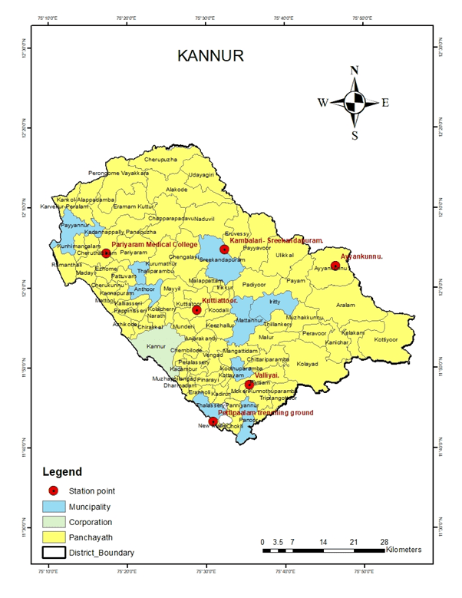

**Figure 13. FSTP site locations in Kannur District**

1. **Kasargod**

Kasargod district consists of 38 Gramapanchayath and 3 Municipalities. The details of 6 identified clusters are shown below.

**Table 15: Identified sites in Kasargod District**

| Sl. No | Proposed site location | Area of land in Cents | Capacity  (in KLD) | Local bodies covered (Number) | | | |
| --- | --- | --- | --- | --- | --- | --- | --- |
| GP | Municipality | Corporation | Total |
| 1 | Madikkunnu. | 50 | 95 | 9 | 2 | 0 | 11 |
| 2 | Cheruppa - Pettkundu. | 100 | 40 | 6 | 0 | 0 | 6 |
| 3 | Mogu-Mudeytheadukka | 100 | 80 | 9 | 0 | 0 | 9 |
| 4 | Minichippadavu. | 100 | 55 | 6 | 1 | 0 | 7 |
| 5 | Nelliyadukkam, Kundumkuzhi. | 50 | 60 | 7 | 0 | 0 | 7 |
| 6 | Mangalpady. | 38 | 12 | 1 | 0 | 0 | 1 |
|  |  | Total | 342 | 38 | 3 | 0 | 41 |

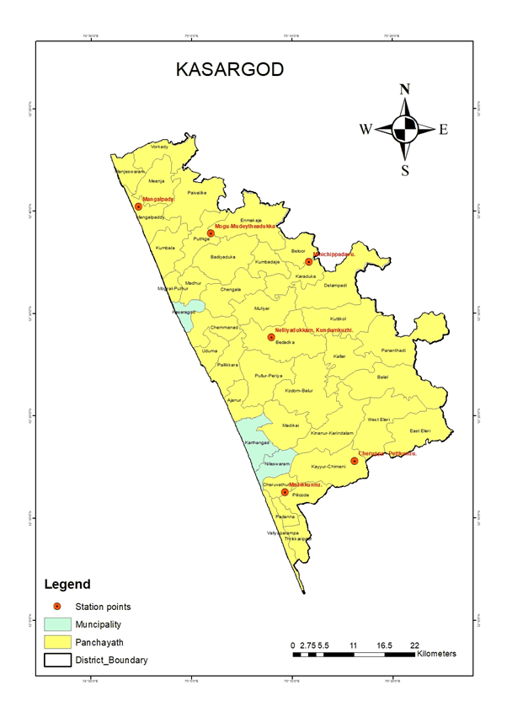

**Figure 14. FSTP site locations in Kasargod District**

# Current plan for FSSM implementation

The first phase of implementation is being executed with the sites where the land is readily available. The readily available and doable faecal sludge treatment plant sites for FSTP commissioning for each district are discussed in the below section.

**Table 16: District-wise sites for FSTP implementation**

|  | **Quarry** | | **Public** | | | **Private** | **Total** | **DPC approved** |
| --- | --- | --- | --- | --- | --- | --- | --- | --- |
| **District** | **Government Quarry** | **Private Quarry** | **Revenue land** | **LSGI Land** | **Other Dept. Land** | **Private Land** |
| Thiruvananthapuram | 0 | 0 | 1 | 1 | 2 | 0 | 4 | 2 |
| Kollam | 0 | 0 | 0 | 0 | 1 | 0 | 1 | 0 |
| Pathanamthitta | 0 | 0 | 0 | 0 | 0 | 1 | 1 | 0 |
| Alappuzha | 0 | 0 | 0 | 3 | 0 | 0 | 3 | 1 |
| Kottayam | 0 | 0 | 0 | 1 | 2 | 0 | 3 | 1 |
| Idukki | 1 | 0 | 0 | 1 | 0 | 0 | 2 | 1 |
| Ernakulam | 0 | 0 | 1 | 1 | 2 | 0 | 4 | 2 |
| Thrissur | 0 | 0 | 0 | 3 | 0 | 0 | 3 | 0 |
| Palakkad | 1 | 1 | 0 | 1 | 0 | 0 | 3 | 0 |
| Malappuram | 0 | 0 | 0 | 3 | 1 | 0 | 4 | 3 |
| Wayanad | 1 | 0 | 0 | 3 | 0 | 0 | 4 | 0 |
| Kozhikode | 0 | 0 | 1 | 2 | 0 | 0 | 3 | 0 |
| Kannur | 0 | 0 | 0 | 2 | 2 | 0 | 4 | 2 |
| Kasargod | 0 | 0 | 0 | 1 | 3 | 0 | 4 | 2 |
| Total | **3** | **1** | **3** | **21** | **14** | **1** | **43** | **14** |

1. **Thiruvananthapuram**

Thiruvananthapuram district has four clusters for the implementation in phase 1 and the district planning committee approval was accorded for two projects. The details of the FSTP projects and the GIS-based clustering is shown in the Table and the Figure below.

**Table 17: Cluster and land details for Phase-1 in Thiruvananthapuram District**

| **Sl. No** | **Proposed site location** | **Area of land in Cents** | **Capacity**  **(in KLD)** | **Local bodies covered (Number)** | | | |
| --- | --- | --- | --- | --- | --- | --- | --- |
| **GP** | **Municipality** | **Corporation** | **Total** |
| 1 | Muttathara |  | 250 | 9 | 0 | 1 | 10 |
| 2 | Pallipuram, Azhoor | 400 | 100 | 16 | 1 | 0 | 17 |
| 3 | Nettukaltheri, Kallikadu | 100 | 100 | 17 | 0 | 0 | 17 |
| 4 | Akethemuri | 50 | 50 | 16 | 1 | 0 | 17 |
|  |  | Total | 500 | 58 | 2 | 1 | 61 |

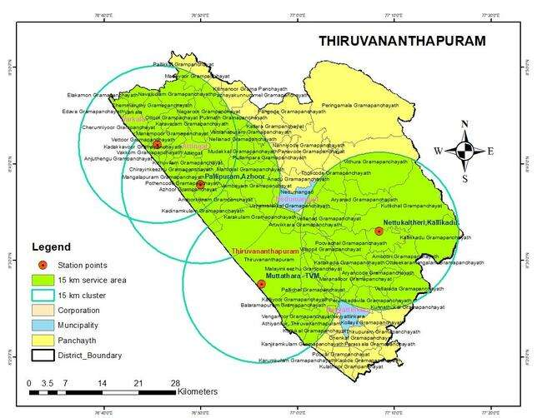

**Figure 15. GIS based cluster map covering LSGIs for Phase-1 in Thiruvananthapuram District**

1. **Kollam**

Kollam district has one cluster for the implementation in phase 1. The details of the FSTP projects and the GIS based clustering is shown in the Table and the Figure below.

**Table 18: Cluster and land details for Phase-1 in Kollam District**

| **Sl. No** | **Proposed site location** | **Area of land in Cents** | **Capacity**  **(in KLD)** | **Local bodies covered (Number)** | | | |
| --- | --- | --- | --- | --- | --- | --- | --- |
| **GP** | **Municipality** | **Corporation** | **Total** |
| 1 | Kuriotumala | 10600 | 100 | 13 | 1 | 0 | 14 |
|  |  | Total | 100 | 13 | 1 | 0 | 14 |

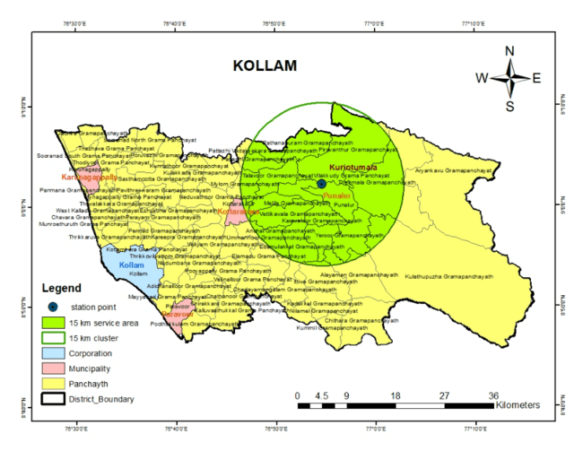

**Figure 16. GIS based cluster map covering LSGIs for Phase-1 in Kollam District**

1. **Pathanamthitta**

Pathanamthitta district has one cluster for the implementation in phase 1. The details of the FSTP projects and the GIS based clustering is shown in the Table and the Figure below.

**Table 19: Cluster and land details for Phase-1 in Pathanamthitta District**

| **Sl. No** | **Proposed site location** | **Area of land in Cents** | **Capacity**  **(in KLD)** | **Local bodies covered (Number)** | | | |
| --- | --- | --- | --- | --- | --- | --- | --- |
| **GP** | **Municipality** | **Corporation** | **Total** |
| 1 | Koodal | 200 | 40 | 7 | 0 | 0 | 7 |
|  |  | Total | 40 | 7 | 0 | 0 | 7 |

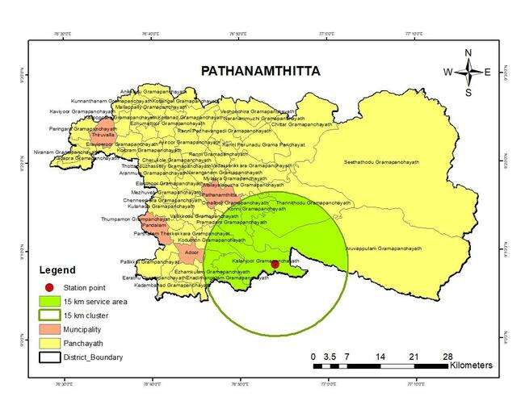

**Figure 17. GIS based cluster map covering LSGIs for Phase-1 in Pathanamthitta District**

1. **Alappuzha**

Alappuzha district has four clusters for the implementation in phase 1. The details of the FSTP projects and the GIS based clustering is shown in the Table and the Figure below.

**Table 20: Cluster and land details for Phase-1 in Alappuzha District**

| **Sl. No** | **Proposed site location** | **Area of land in Cents** | **Capacity**  **(in KLD)** | **Local bodies covered (Number)** | | | |
| --- | --- | --- | --- | --- | --- | --- | --- |
| **GP** | **Municipality** | **Corporation** | **Total** |
| 1 | Cherthala - Anatharaveli | 50 | 250 | 15 | 1 | 0 | 16 |
| 2 | Mavelikkara Thekkekara - Kurathikad | 50 | 70 | 10 | 1 | 0 | 11 |
| 3 | Palamel | 100 | 50 | 9 | 0 | 0 | 9 |
|  |  | Total | 370 | 34 | 2 | 0 | 36 |

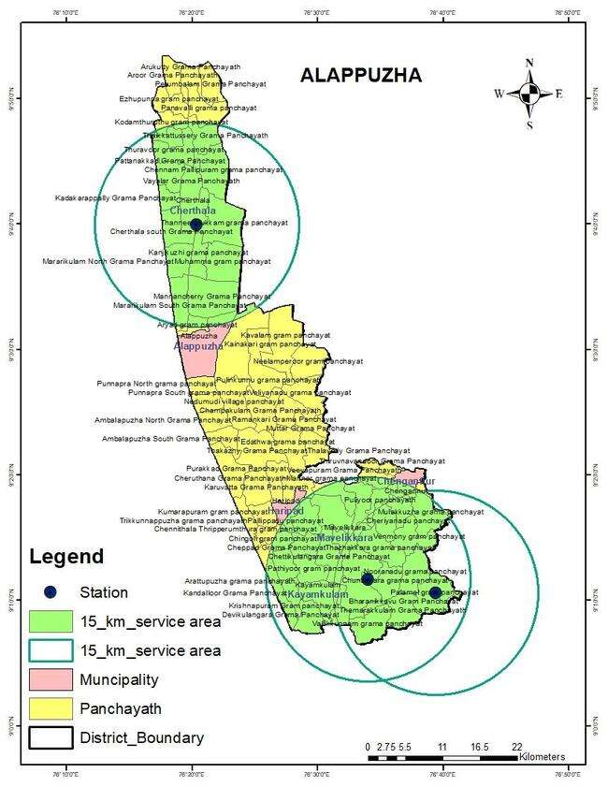

**Figure 18. GIS based cluster map covering LSGIs for Phase-1 in Alappuzha District**

1. **Kottayam**

Kottayam district has three clusters for the implementation in phase 1 and one project was accorded District Planning Committee approval. The details of the FSTP projects and the GIS based clustering is shown in the Table and the Figure below.

| **Sl. No** | **Proposed site location** | **Area of land in Cents** | **Capacity**  **(in KLD)** | **Local bodies covered (Number)** | | | |
| --- | --- | --- | --- | --- | --- | --- | --- |
| **GP** | **Municipality** | **Corporation** | **Total** |
| 1 | Erumeli | 250 | 113 | 7 | 0 | 0 | 7 |
| 2 | Medical College, Kottayam | 300 | 89 | 15 | 1 | 0 | 16 |
| 3 | Pipe yard quarters, Manganam | 200 | 140 | 15 | 2 | 0 | 17 |
|  |  | Total | 342 | 37 | 3 | 0 | 40 |

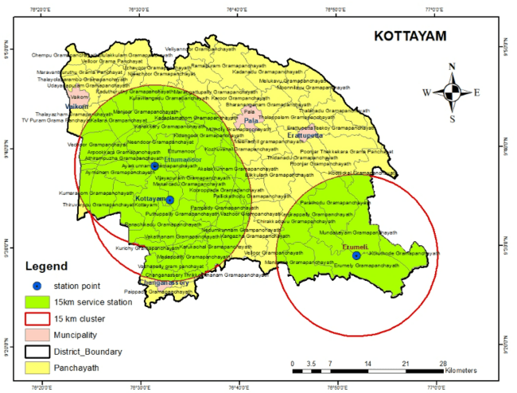

**Figure 19. GIS based cluster map covering LSGIs for Phase-1 in Kottayam District**

1. **Idukki**

Idukki district has two clusters for the implementation in phase 1. The details of the FSTP projects and the GIS based clustering is shown in the Table and the Figure below.

**Table 22: Cluster and land details for Phase-1 in Idukki District**

| **Sl. No** | **Proposed site location** | **Area of land in Cents** | **Capacity**  **(in KLD)** | **Local bodies covered (Number)** | | | |
| --- | --- | --- | --- | --- | --- | --- | --- |
| **GP** | **Municipality** | **Corporation** | **Total** |
| 1 | Munnar | 25 | 50 | 7 | 0 | 0 | 7 |
| 2 | Kattapana | 245.02 | 78 | 12 | 1 | 0 | 13 |
|  |  | Total | 128 | 19 | 1 | 0 | 20 |

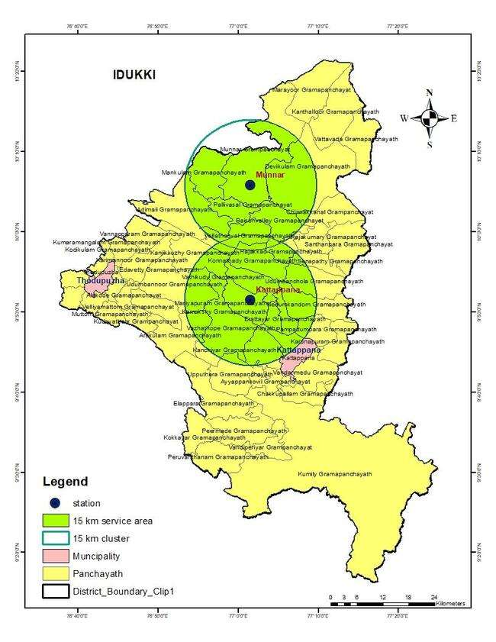

**Figure 20. GIS based cluster map covering LSGIs for Phase-1 in Idukki District**

1. **Ernakulam**

Ernakulam district has four clusters for the implementation in phase 1 and two projects were accorded District Planning Committee approval. The details of the FSTP projects and the GIS based clustering is shown in the Table and the Figure below.

**Table 23: Cluster and land details for Phase-1 in Ernakulam District**

| **Sl. No** | **Proposed site location** | **Area of land in Cents** | **Capacity**  **(in KLD)** | **Local bodies covered (Number)** | | | |
| --- | --- | --- | --- | --- | --- | --- | --- |
| **GP** | **Municipality** | **Corporation** | **Total** |
| 1 | Vedimara. | 60 | 50 | 13 | 2 | 0 | 15 |
| 2 | Kottakkunnu. | 60 | 10 | 15 | 2 | 0 | 17 |
| 3 | Elamkulam | 100 | 250 | 13 | 4 | 1 | 18 |
| 4 | Varapetti | 70 | 30 | 19 | 2 | 0 | 21 |
|  |  | Total | 340 | 60 | 10 | 1 | 71 |

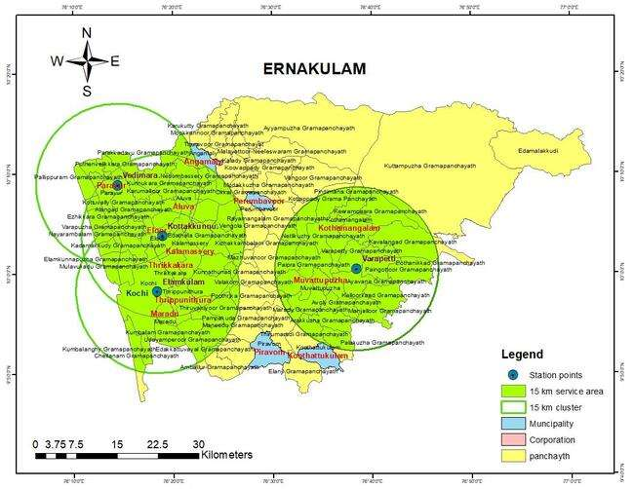

**Figure 21. GIS based cluster map covering LSGIs for Phase-1 in Ernakulam District**

1. **Thrissur**

Thrissur district has three clusters for the implementation in phase 1. The details of the FSTP projects and the GIS based clustering is shown in the Table and the Figure below.

**Table 24: Cluster and land details for Phase-1 in Thrissur District**

| **Sl. No** | **Proposed site location** | **Area of land in Cents** | **Capacity**  **(in KLD)** | **Local bodies covered (Number)** | | | |
| --- | --- | --- | --- | --- | --- | --- | --- |
| **GP** | **Municipality** | **Corporation** | **Total** |
| 1 | Madakkathara | -- | 10 | 10 | 0 | 0 | 10 |
| 2 | Chelakkara Farm | 120 | 85 | 11 | 1 | 0 | 12 |
| 3 | Venginissery | 50 | 10 | 25 | 1 | 1 | 27 |
|  |  | Total | 105 | 46 | 2 | 1 | 49 |

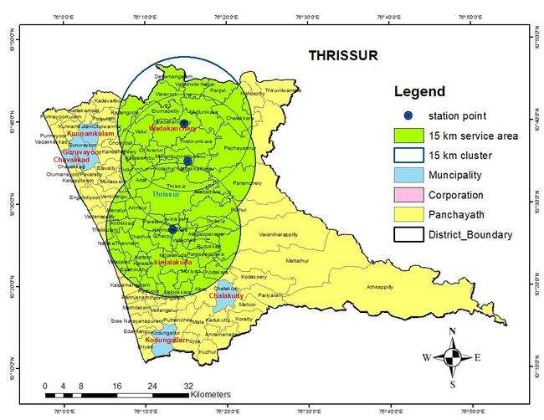

**Figure 22. GIS based cluster map covering LSGIs for Phase-1 in Thrissur District**

1. **Palakkad**

Palakkad district has three clusters for implementation in phase 1. The details of the FSTP projects and the GIS based clustering is shown in the Table and the Figure below.

**Table 25: Cluster and land details for Phase-1 in Palakkad District**

| **Sl. No** | **Proposed site location** | **Area of land in Cents** | **Capacity**  **(in KLD)** | **Local bodies covered (Number)** | | | |
| --- | --- | --- | --- | --- | --- | --- | --- |
| **GP** | **Municipality** | **Corporation** | **Total** |
| 1 | Thrithala | 1000 | 135 | 15 | 1 | 0 | 16 |
| 2 | Muthalamada | 200 | 96 | 10 | 1 | 0 | 11 |
| 3 | Ayiloor | 425 | 82 | 14 | 0 | 0 | 14 |
|  |  | Total | 313 | 39 | 2 | 0 | 41 |

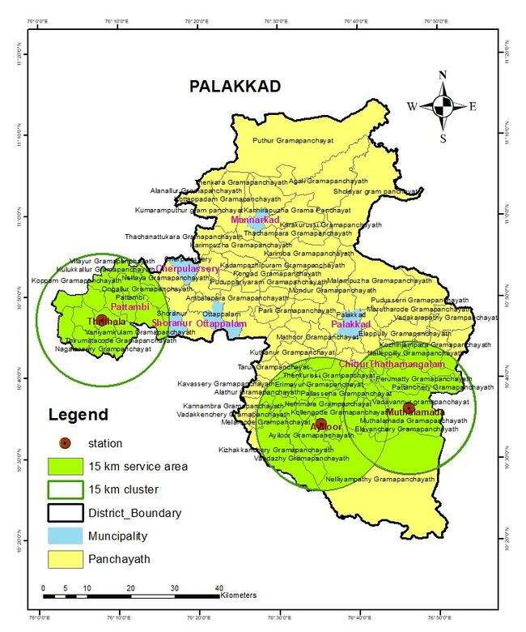

**Figure 23. GIS based cluster map covering LSGIs for Phase-1 in Palakkad District**

1. **Malappuram**

Malappuram district has three clusters for the implementation in phase 1 and three projects were accorded District Planning Committee approval. The details of the FSTP projects and the GIS based clustering is shown in the Table and the Figure below.

**Table 26: Cluster and land details for Phase-1 in Malappuram District**

| **Sl. No** | **Proposed site location** | **Area of land in Cents** | **Capacity**  **(in KLD)** | **Local bodies covered (Number)** | | | |
| --- | --- | --- | --- | --- | --- | --- | --- |
| **GP** | **Municipality** | **Corporation** | **Total** |
| 1 | Perinthalmanna. | 550 | 100 | 9 | 1 | 0 | 10 |
| 2 | Tirur Ground | 200 | 100 | 17 | 4 | 0 | 21 |
| 3 | Valancheri | 250 | 100 | 15 | 2 | 0 | 17 |
| 4 | Narukara | 650 | 178 | 15 | 2 | 0 | 17 |
|  |  | Total | 478 | 56 | 9 | 0 | 65 |

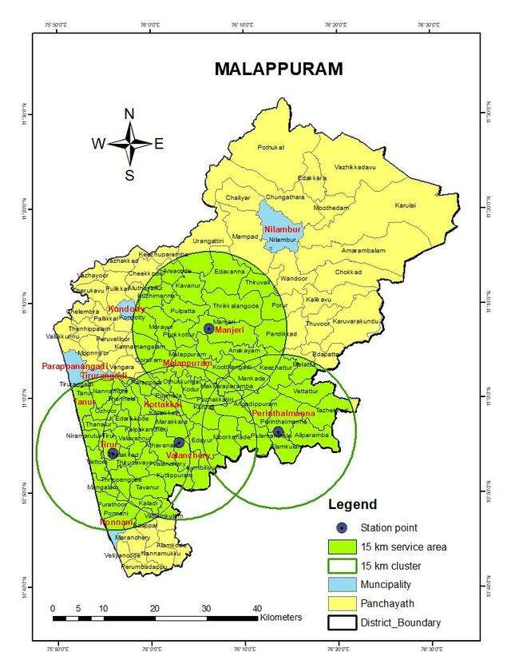

**Figure 24. GIS based cluster map covering LSGIs for Phase-1 in Malappuram District**

1. **Wayanad**

Wayanad district has four clusters for the implementation in phase 1. The details of the FSTP projects and the GIS based clustering is shown in the Table and the Figure below.

**Table 27: Cluster and land details for Phase-1 in Wayanad District**

| **Sl. No** | **Proposed site location** | **Area of land in Cents** | **Capacity**  **(in KLD)** | **Local bodies covered (Number)** | | | |
| --- | --- | --- | --- | --- | --- | --- | --- |
| **GP** | **Municipality** | **Corporation** | **Total** |
| 1 | Vellaramkunnu - Kalpetta | 55 | 10 | 6 | 1 | 0 | 7 |
| 2 | Aarattupura- Ambalavayal | 800 | 55 | 4 | 0 | 0 | 4 |
| 3 | Pulppalli | 75 | 35 | 5 | 1 | 0 | 6 |
| 4 | Vellamunda | 150 | 65 | 6 | 1 | 0 | 7 |
|  |  | Total | 165 | 21 | 3 | 0 | 24 |

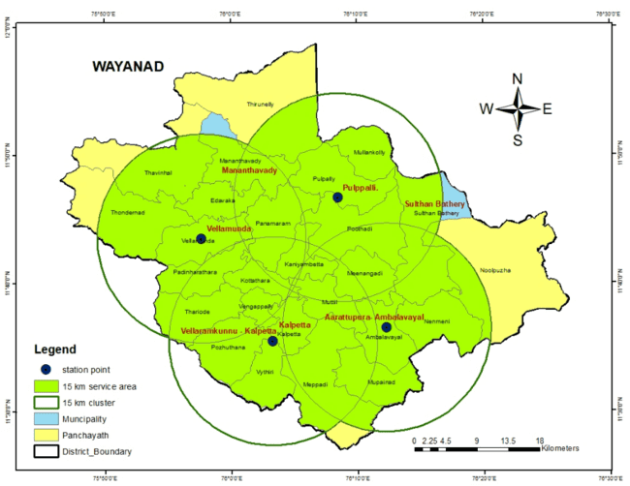

**Figure 25. GIS based cluster map covering LSGIs for Phase-1 in Wayanad District**

1. **Kozhikode**

Kozhikode district has three clusters for the implementation in phase 1. The details of the FSTP projects and the GIS based clustering is shown in the Table and the Figure below.

**Table 28: Cluster and land details for Phase-1 in Kozhikode District**

| **Sl. No** | **Proposed site location** | **Area of land in Cents** | **Capacity**  **(in KLD)** | **Local bodies covered (Number)** | | | |
| --- | --- | --- | --- | --- | --- | --- | --- |
| **GP** | **Municipality** | **Corporation** | **Total** |
| 1 | Thamarassery | 400 | 168 | 10 | 1 | 0 | 11 |
| 2 | Meppayur | 125 | 253 | 24 | 3 | 0 | 27 |
| 3 | Mukkom | 500 | 225 | 9 | 2 | 1 | 12 |
|  |  | Total | 646 | 43 | 6 | 1 | 50 |

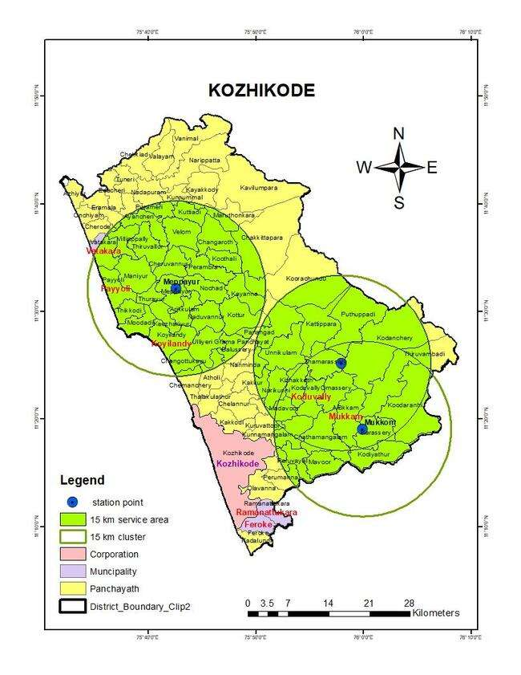

**Figure 26. GIS based cluster map covering LSGIs for Phase-1 in Kozhikode District**

1. **Kannur**

Kannur district has four clusters for the implementation in phase 1 and two projects were accorded District Planning Committee approval. The details of the FSTP projects and the GIS based clustering is shown in the Table and the Figure below.

**Table 29: Cluster and land details for Phase-1 in Kannur District**

| **Sl. No** | **Proposed site location** | **Area of land in Cents** | **Capacity**  **(in KLD)** | **Local bodies covered (Number)** | | | |
| --- | --- | --- | --- | --- | --- | --- | --- |
| **GP** | **Municipality** | **Corporation** | **Total** |
| 1 | Valliyai | 100 | 50 | 11 | 3 | 0 | 14 |
| 2 | Chelora | 50 | 100 | 15 | 1 | 1 | 17 |
| 3 | WSS- Thalasseri, Keezhallur | 100 | 82 | 11 | 2 | 0 | 13 |
| 4 | Pariyaram Medical College | 50 | 164 | 15 | 2 | 0 | 17 |
|  |  | Total | 396 | 52 | 8 | 1 | 61 |

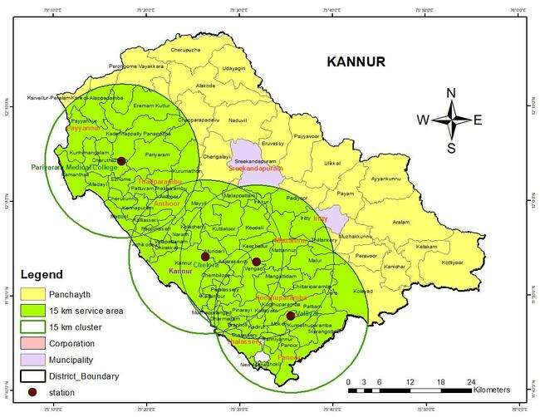

**Figure 27. GIS based cluster map covering LSGIs for Phase-1 in Kannur District**

1. **Kasargod**

Kasargod district has four clusters for the implementation in phase 1 and three projects were accorded were accorded District Planning Committee approval. The details of the FSTP projects and the GIS based clustering is shown in the Table and the Figure below.

**Table 30: Cluster and land details for Phase-1 in Kasargod District**

| **Sl. No** | **Proposed site location** | **Area of land in Cents** | **Capacity**  **(in KLD)** | **Local bodies covered (Number)** | | | |
| --- | --- | --- | --- | --- | --- | --- | --- |
| **GP** | **Municipality** | **Corporation** | **Total** |
| 1 | Madikkunnu. | 50 | 30 | 5 | 0 | 0 | 5 |
| 2 | Kundamkuzhy | 50 | 60 | 13 | 1 | 0 | 14 |
| 3 | Puthukai | 345 | 40 | 2 | 2 | 0 | 4 |
| 4 | Kayyur Cheemeni | 100 | 25 | 4 | 0 | 0 | 4 |
|  |  | Total | 155 | 24 | 3 | 0 | 27 |

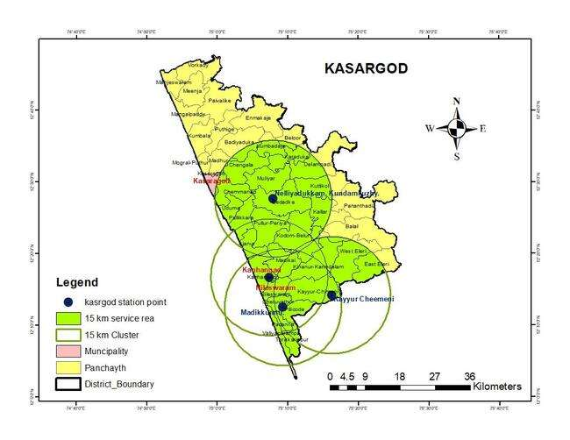

**Figure 28. GIS based cluster map covering LSGIs for Phase-1 in Kasargod District**

# Way forward

## 6.1 Institutional Strengthening

Institutional strengthening activities will be executed for the improved FSSM services delivery in the districts.

### Strengthening of LSGI:

LSGI would play a central role in the planning, implementation, management, and monitoring of both the infrastructural and non-infrastructural components of the FSSM. Thus, LSGIs need to be empowered with additional funds and the ability to engage the requisite human resources to manage the FSSM successfully.

### District Water and Sanitation Committee

The District-level Coordination Committee in the districts under the chairmanship of the District Collector will be assigned to periodically review the FSSM activities

The committee has to provide guidance in planning and implementation of the FSSM activities and monitor the progress as per its expected deliverables and milestones. To facilitate the implementation of FSTPs in the clusters the committee has to take up the coordination of the activities of line department in frontline.

Below are the key responsibilities of the District level Coordination committee in terms of FSSM implementation

* Facilitate allotment of land for the establishment of the FSTP
* Facilitate the selection of technology best suited to the local context
* Facilitate the development of O&M model of the FSSM
* Aid the determination of the desludging tariff based on criteria like the socio-economic condition of the household, the distance from FSTP, and others.

### Empanelment of agencies for FSTP technology service providers

A meeting was conducted by the state Suchitwa Mission for drafting an expression of interest to establish Faecal Sludge Treatment plants in Kerala and based on that agencies will be empanelled to undertake FSTP projects in Kerala in the month of June. This will ease the identification of private treatment service providers for FSTP implementation by the LSGIs with DBOT model.

### Capacity Building of LSGI Engineers

The capacities and competencies of district-, block, and LSGI-level governmental actors, service providers, and community groups need to be enhanced to enable them to plan, deliver, and monitor FSM services as each of them play a crucial role in the FSSM services. As a first phase, the LSGI engineers who are the implementing officials of FSTP projects were given orientation training on FSSM for the smooth implementation of FSTP projects in the LSGIs. The oriented engineers were taken to an FSTP for getting exposure on fecal sludge treatment plant processes.

### Exposure visit to best practice cities

Study visits the best FSM models within and outside of the state could be arranged for the LSGI functionaries and government officials to enhance their motivation and knowledge based on on-ground experience. The elected representatives from the Kasargod district were taken to Devanahalli to replicate and customize the best practices to their LSGI. Similarly, other LSGIs from the state will undergo study visits and get handholding support from the state Suchitwa Mission for undertaking study tours and implementing LWM initiatives in their respective LSGIs.

### Safety practices during desludging operations for Sanitation workers

Desludging operators will be trained to deliver desludging services safely by imparting education on the use of safety gears and equipment, first aid basics, and the O&M requirements of the desludging vehicle. The safety training is being planned to be delivered by the master trainers who will train the resource persons at district and block levels. The trained resource persons will train the sanitation workers to use safe practices in FSSM services. Additionally, the state Suchitwa Mission has drafted guidelines for sanitation worker safety and dignity with responsibilities of each stakeholder (households, LSGI, sanitation worker, and treatment service provider), a list of all Personal Protective Equipment (PPE) with their prices in the government portal to ease the procurement by LSGIs and the document will be made available for all LSGI to ensure safety and dignity of sanitation workers..

## 6.2 Information, Education and Communication (IEC) activities

### Malambhootham Campaign

Malambhootham is an extensive mass education programme conducted by the Local Self Government Department and Suchitwa Mission to make people aware of the need for the scientific treatment of toilet waste.

Through the campaign, people will be made aware of the dangers of not maintaining toilet waste scientifically and the LSGI will be pushed for establishing a Faecal Sludge Treatment Plant or treatment unit. The campaign is being taken by each district Suchitwa Mission to create awareness on the need of regular emptying of septic tanks and show the urgency of creating the infrastructure for faecal waste treatment.

## 6.3 Revenue model and Financing mechanism for FSSM

FSTP infrastructures are being planned with the capital funds from Swacch Bharat Mission (SBM-G) funds of 426 crores which has been allocated for the state. Also, the LSGI can utilise the Urban Agglomeration Funds or 15th Central Finance Committee funds. Regulated private sector engagement for emptying is being planned through the sanitation workers and so, issuance of license to emptier will be initiated. The parties operating without licenses will be penalised by the LSGI. LSGI will allocate the funds for operational costs from the cost allocated for LWM activities. The by-product from FSTP will be marketed and the revenue shall be taken by the LSGI or DBOT contractor as per the contract/agreement.

# Current status in the FSSM Implementation

As per the SBM G guidelines there should be at least 2 FSTP plants in each district for catering the septage generated in the state. As per the FSSM workshop conducted by Suchitwa Mission, 88 sites were identified and 43 sites were given priority as there is less public agitation. Among these sites, 1 site at Venginissry, Thrissur was found unsuitable as per the KSPCB report, and another site at Akethemuri, Thiruvananthapuram was dropped from the plan as another project of the same kind is proposed nearby.

Apart from funding from/through Suchitwa Mission, projects utilising funding from AMRUT, RKI, Urban Agllomeration/CFC and LSGI own fund for construction of FSTP are also taken up. The following table shows the overall summary of FSM actions implemented, planned in the state.

**Table 28: Summary status of FSTPs across the state**

| **Sl. No** | **District** | **Existing** | **Ongoing** | **DPC Approvedprojects** | **To be Approved** | **Total** |
| --- | --- | --- | --- | --- | --- | --- |
| 1 | Alappuzha | 0 | 1 | 1 | 1 | **3** |
| 2 | Ernakulam | 2 | 0 | 3 | 2 | **7** |
| 3 | Idukki | 0 | 1 | 0 | 1 | **2** |
| 4 | Kannur | 0 | 0 | 2 | 2 | **4** |
| 5 | Kasargod | 0 | 0 | 2 | 2 | **4** |
| 6 | Kollam | 0 | 0 | 1 | 0 | **1** |
| 7 | Kottayam | 0 | 0 | 1 | 2 | **3** |
| 8 | Kozhikode | 0 | 0 | 0 | 3 | **3** |
| 9 | Malappuram | 0 | 0 | 3 | 1 | **4** |
| 10 | Palakkad | 0 | 0 | 1 | 3 | **4** |
| 11 | Pathanamthitta | 0 | 0 | 0 | 0 | **0** |
| 12 | Thiruvananthapuram | 0 | 0 | 4 | 0 | **4** |
| 13 | Thrissur | 1 | 0 | 2 | 0 | **3** |
| 14 | Wayanad | 1 | 0 | 0 | 3 | **4** |
|  | **Total** | **4** | **2** | **20** | **20** | **46** |

## 7.1 Ongoing Projects

There are two projects currently ongoing for FSTP. The details and current status is shown below in the table.

**Table 29: Details of Ongoing FSTP projects**

| Sl No | Name | Capacity in KLD | Agency | Status |
| --- | --- | --- | --- | --- |
| 1 | Cherthala, Alappuzha | 250 | RKI | Work in progress |
| 2 | Munnar, Idukki | 50 | SBM - G | Construction started. Stayed due to court order |

## 7.2 DPC Approved / Proposed Projects

There are 20 projects which can be considered as prioritized for timely implementation. The details and status of those projects are enlisted below.

**Table 30: Details of DPC Approved / Proposed FSTP projects**

| **Sl No** | **District** | **Name of the site** | **Capacity in KLD** | **Agency** | **Status** |
| --- | --- | --- | --- | --- | --- |
| 1 | Alappuzha | Mavelikkara Thekkekara | 70 | SBM - G | Agency submitted the DPR to the local body |
| 2 | Ernakulam | Brahmapuram | 1000 | AMRUT 2.0 | Council approval to be obtained |
| 3 | Ernakulam | Vedimara | 50 | LSG - Fund | Council approved for the call for EOI for DPR Preparation |
| 4 | Ernakulam | Kottakkunnu | 10 | LSG - Fund | IRTC Submitted PFR, Proposal to be submitted to FACT through Honorable Industries Minister PM Rajeev for NOC |
| 5 | Kannur | Chelora | 100 | AMRUT 1.0 | Council approval accorded. The project will be sent for vetting shortly |
| 6 | Kannur | Valliyayi | 50 | SBM - G | Agreement Executed for DPR Preperation |
| 7 | Kasargod | Madikkunnu | 95 | SBM - G | Land transfer process is underway. PWD submitted the land report to Collector |
| 8 | Kasargod | Bedadukka | 60 | SBM - G | Panchayat level meeting with agency and SM director held on 20.07.2023 |
| 9 | Kollam | Karunagappally | 100 | LSG - Fund | Agency prepared the DPR and submitted for vetting |
| 10 | Kottayam | Erumeli | 113 | SBM - G | Tender opened. Work order to be issued |
| 11 | Malappuram | Perinthelmanna | 100 | LSG - Fund | DPR under construction. |
| 12 | Malappuram | Tirur | 100 | LSG - Fund | Retendered for DBOT |
| 13 | Malappuram | Valancheri | 100 | UA - Fund | DPR submitted |
| 14 | Palakkad | Yakkara | 100 | AMRUT 1.0 | Tendering called for DPR Preperation. DBO tender to be finalized by ULB |
| 15 | Thiruvananthapuram | Varkala | 50 | RKI | Tender called for DPR Preparation. Tender will be opened on August last week |
| 16 | Thiruvananthapuram | Azhoor | 100 | SBM - G | DBOT Tender called for the FSTP Project. |
| 17 | Thiruvananthapuram | Kallikadu | 100 | SBM - G | NoC from Home Dept needed |
| 18 | Thiruvananthapuram | Attingal | 20 | UA - Fund | Project approved. Meeting convened on 4th August to decide mode of tender and technology |
| 19 | Thrissur | Ramavarmapuram | 100 | AMRUT 1.0 | DPR Tendered. Vetted design and technical details submitted by the agency |
| 20 | Thrissur | Chelakkara | 85 | SBM - G | DPC approved, Tendering activity yet to take. Pilot study completed |

## 7.3 Mobile FSTPs

There are 6 Mobile FSTP projects included in the annual plan of LSGIs. Some of these projects are taken as per the SBM-Kosh scheme. The details pertaining to Mobile FSTPs are given below.

**Table 31: Details of Mobile FSTP projects**

| **Sl No** | **Name of the site** | **District** | **Capacity in KLD** | **Agency** | **Status** |
| --- | --- | --- | --- | --- | --- |
| 1 | Alappuzha | Alappuzha | 10 | AMRUT 1.0 | DPR Tendered. Awaiting for the vetted DPR. |
| 2 | Alappuzha | Alappuzha | 10 | AMRUT 1.0 | DPR Tendered. Awaiting for the vetted DPR. |
| 3 | Chirayinkeezhu | Thiruvananthapuram | 6 | SBM - Kosh | Project sanctioned. Fund release is pending from Swach bharath Kosh |
| 4 | Neyyatinkara | Thiruvananthapuram | 6 | SK U and CFC | Under Technical Scrutiny |
| 5 | Kodunagalloor | Thrissur | 6 | SK U and CFC | Project approved |
| 6 | Chalakkudy | Thrissur | 6 | SK U and CFC | Under Technical Scrutiny |

## 7.4 FSTP Projects to be approved

These projects are yet to get approval. Some of the sites got sanctions from the parent department.

**Table 32: Details of FSTP projects to be approved**

| **Sl. No** | **District** | **LSGI** | **Proposed Site Location** | **Type of Land** | **Status** |
| --- | --- | --- | --- | --- | --- |
| 1 | Alappuzha | Palamel GP | Palamel | Other Department (Home) | Sanction needed, having public protest |
| 2 | Ernakulam | Kochi Corporation | Elamkulam | Other Department (KWA) | Permissive sanction received, Council not approved the proposal |
| 3 | Ernakulam | Varapetti GP | Varapetti | Revenue Land | Sanction needed, GP sent letter to collector |
| 4 | Idukki | Kattapana Municipality | Kattappana | Government Quarry | Resolution yet to pass by the Municipality |
| 5 | Kannur | Kadannappally- Panapuzha GP | Pariyaram Medical College | Other Department (Health) | Instruction given to look for another land. Inspection to be conducted before Aug 5 |
| 6 | Kannur | Keezhallur GP | Thalasseri | Other Department (KWA) | The location is so close to two proposed FSTP (Kannur&Panoor Block) projects, the project's necessity must be assessed. |
| 7 | Kasargod | Kanhangad Municipality | Puthukai | Other Department ( Industries) | DC instructed to transfer 1 acre of land. Currently land survey is being conducted |
| 8 | Kasargod | Kayyur Cheemeni GP | Kayyur Cheemeni | Other Department (Jail) | Need Sanction from Jail Department |
| 9 | Kottayam | Arpookara GP | Medical College, Kottayam | Other Department  (Medical Education) | Permissive sanction not received from DME |
| 10 | Kottayam | Kottayam Municipality | Manganam | Other Department (KWA) | Permissive sanction received from KWA and Project taken by District Panchayath |
| 11 | Kozhikode | Thamarassery GP | Thamarassery. | LSGI Land | Planning to conduct a meeting with District Collector |
| 12 | Kozhikode | Meppayur GP | Meppayur | LSGI Land | Land details collected from Village office. |
| 13 | Kozhikode | Mukkom Municipality | Mukkom | Revenue Land | Land identification under process |
| 14 | Malappuram | Manjeri Municipality | Narukara | Other Department (KWA) | Permissive sanction received from KWA |
| 15 | Palakkad | Ayiloor GP | Ayiloor. | Government Quarry | Visit to Muttathara plant scheduled to overcome public protest |
| 16 | Palakkad | Palakkad DP | Muthalamada. | LSGI Land | Need Sanction from Agriculture Department |
| 17 | Palakkad | Thrithala GP | Thrithala. | Private Quarry | Required area to be marked after doing preliminary study |
| 18 | Wayanad | Ambalavayal GP | Aarattupura | Government Quarry | Land allocation letter sent to LRC |
| 19 | Wayanad | Pulappalli GP | Pulppalli. | LSGI Land | Road access is to be acquired from the Forestry department. Application is being done through Parivesh Portal |
| 20 | Wayanad | Vellamunda GP | Vellamunda | LSGI Land | Planning for meeting with MLA and GP to discuss about public protest |

## 