

**Policy on Faecal Sludge and Septage Management for Kerala**

**January 2025**

**Thiruvananthapuram**

1.Introduction to Faecal Sludge and Septage Management 3

1.1 FSSM service chain or Sanitation Value chain 3

1.3 Scenario of FSSM in Kerala 4

1.4 Scope of the Policy 4

1.5 Objectives of the Policy 4

2. Roles and Responsibilities of stakeholders on FSSM implementation 5

3. Clustering of LSG for FSTP 6

4. Technology options for Faecal Sludge and Septage Management 6

4.2 Co-treatment of septage in STP 8

6. Revenue Models for FSSM 9

Discrete collection & Treatment Model 9

7. Funding for FSTP 10

### 

### **1.Introduction to Faecal Sludge and Septage Management**

Faecal Sludge or Septage accumulates in onsite sanitation systems like septic tanks, pit latrines or dry toilet systems. It is solid, semi-solid or a fluid like material, which is partially digested in the onsite sanitation systems and requires further treatment to remove or kill the harmful pathogens present. Faecal Sludge and Septage Management includes storage, emptying, transport and safe end-use or disposal. Poor management of septage causes severe environmental and public health risks.

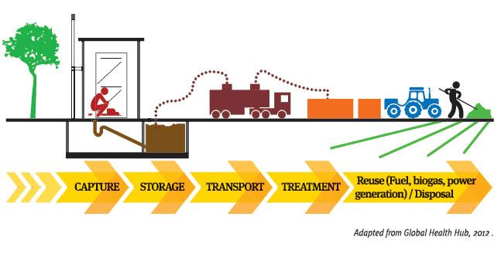

### 1.1 FSSM service chain or Sanitation Value chain

**Storage (Toilet & Containment)**

Faecal sludge and septage is stored in a safe onsite system for designated years, usually 2 to 3 years depending on the type of the system.

**Emptying and Transport**

It is safe emptying of septage from the onsite sanitation systems. Emptying and transport of septage vary based on the type of location, sanitation system and emptying mechanism available. Emptying trucks, trolleys or other vehicles are used to empty the septage from establishments in Kerala. The emptying sector is mostly unregulated and managed by the private agencies in Kerala.

**Treatment**

Septage can be treated in a standalone faecal sludge treatment plant or sewage treatment plant through co-treatment. The treatment method is dependent on quality, quantity, geography and land availability. The septage treatment is generally initiated through solid liquid separation. The treatment can be nature based or electro mechanical.

**Safe reuse or disposal**

The processed septage can be safely reused as soil conditioner (after removing pathogens), fuel, or biochar. The reuse of septage is subject to the type of septage treatment executed.

### 1.3 Scenario of FSSM in Kerala

Kerala achieved Open Defecation Free (ODF) status in the year 2016, but the state is faced with a second-generation challenge of faecal contamination of water bodies. The water sources of the state are contaminated by the pollutants entering the water bodies and the environment through indiscriminate disposal of septage and lack of treatment infrastructure resulting in public and environmental health risks. The state is predominantly served by the onsite sanitation systems (OSS) and the networked sanitation coverage is minimal in the state.

Presently, faecal waste is treated in Thiruvananthapuram through co-treatment at Sewage Treatment Plant (STP), Kochi through two FSTPs, Kalpetta and Wayanad through FSTPs. Roughly less than 10% of faecal sludge generated is being treated or safely managed in the state.

### 1.4 Scope of the Policy

This FSSM policy will focus on onsite sanitation systems and the areas served by them, excluding networked or conventional sewerage systems (including wastewater/sewage treatment plants). However, the policy recognizes the importance of synergies between septage management and sewerage systems, as well as municipal solid waste (MSW) management, such as co-treatment of septage at sewage treatment plants or alongside MSW management. These integrated approaches will be encouraged. The policy covers the entire service chain, including the transportation, treatment, and reuse or disposal of faecal sludge and septage.

### 1.5 Objectives of the Policy

**The objectives of the FSSM policy are**

**(i) Adoption of Sustainable FSSM Services**: Ensure the adoption of sustainable Faecal Sludge and Septage Management (FSSM) services that are inclusive and equitable for all citizens.

**(ii) Pollution-Free Environment**: Promote an environment free from pollution and health hazards for all citizens.

**(iii) Public and Private Sector Support**: Facilitate collaboration between the public and private sectors under the guidance of a sector regulator for effective implementation.

**(iv) Prioritization of Marginalized Communities**: Address the needs of marginalized communities, particularly those who wish to continue using on-site sanitation systems, ensuring equity in service provision.

**(v) Reduction of Pollution in the Ecosystem**: Focus on reducing pollution in the surrounding ecosystem by effectively managing faecal sludge generated in the state.

**(vi) Clear Roles and Responsibilities**: Define the roles and responsibilities of various stakeholders involved in FSSM implementation.

**(vii) Promotion of FSSM Technologies**: Provide a variety of FSSM technologies for implementation, ensuring adaptability to different contexts and needs.

### 2. Roles and Responsibilities of stakeholders on FSSM implementation

**Local Self Governments**

1. The internal and external roads, power supply, water connection and telephone connection for the FSTP are to be arranged by LSGs
2. Allocation of funds for CAPEX through SBM-G or Urban funds or 15th FC funds and OPEX funds through own fund sources.
3. Licensing or regulating the desludging operator with places of emptying the collected septage and regulated the emptying fee collected by them
4. Owning the FSTP infrastructure from establishment till the sustainable operation
5. Ensuring the construction of proper septic tank through capacity building of all the stakeholders involved
6. Maintaining all the public toilets through private agencies with service agreements
7. Provision of regulatory mechanism to administer the FSSM services in the LSG through FSSM byelaws.
8. IEC for holistic FSSM services from toilet to treatment or reuse.
9. Timely release of the funds to the operation and maintenance agencies who operate the public toilets, desludging and the FSTPs
10. Coordinate among the cluster LSGs regarding the waste transport and treatment in their LSGs.

**Suchitwa Mission**

1. Empanelment of service providers and technologies for establishment of FSTPs
2. Provide Technical Sanctions (TS) for the FSTP projects formulated by the LSGs after the verification of the proposals.
3. Provision of technical advisory support to the LSGs regarding FSSM strategy, rules, funding and guidelines.
4. Facilitating the capacity building programs for sustainable implementation of FSSM initiatives by the LSGs
5. Engaging the private and non-governmental stakeholders for the technical advisory support and IEC support for campaigning on the importance of FSSM services.
6. Provision of capacity building materials based on different target groups for the FSSM implementation and provision of human resources support for capacity building activities.
7. Preparation of standard operating procedure for FSSM covering households, desludging operators and treatment plant operators.

**Kerala State Pollution Control Board**

1. Ensure compliance of FSSM operations through regular inspections and environmental monitoring.
2. Assist in formulation of relevant advisories, guidelines, manuals, etc. to ensure environmental compliance for FSSM operations
3. Provision of inputs to Suchitwa mission in their technical advisory support.

**Desludging operators or Septage emptiers**

1. Timely collection of the Faecal waste from the households upon receiving the request and disposing the collected waste at the designated place or FSTP.
2. Regular maintenance of the vehicles and desludging equipment
3. Maintenance of log book of the waste collection, manifest and reports
4. Adherence to all the applicable regulations fixated by the LSG or the government
5. Regular use of PPE and following all safety protocols while emptying the containment systems

**Masons**

1. To undertake the training for the construction of proper septic tanks and toilets.
2. Discouraging the cost cutting measures and the improper containment system or toilets in their areas of operation

**FSTP operators**

1. Maintenance of log books, record of the influent and effluent characteristics and sludge quantity generated in the FSTP.
2. Adherence to the standard operating procedures issued by the LSGs and the governmental bodies.

### 3. **Clustering of LSG for FSTP**

Establishing individual FSTPs for every LSG is not only uneconomical but also not feasible. Cluster based approach will be ideal for the establishing FSTPs. A maximum travel distance of 15 km may be fixed for the desludging vehicle for carrying the load from the point of extraction to the treatment plant. Clusters are to be formed based on the distance criteria from the identified treatment unit site.

### 4. Technology options for Faecal Sludge and Septage Management

Treatment options for faecal sludge/septage are based on four treatment objectives.

These four mechanisms enable sludge to be handled, disposed of, and/or re-used safely.

a) Solid liquid separation: Solid liquid separation is the first step for successful treatment of faecal sludge, as refuse must be brought to some sort of uniform consistency.

b) Dewatering: Before treatment, faecal sludge is over 80-90% water by volume; de-watering is necessary to reduce volume/weight and destroy the habitat that allows dangerous pathogens to grow.

c) Stabilization: Stabilization refers to several biological and chemical processes through which ongoing biological-chemical reactions run their course and nutrients are consumed by bacteria.

d) Reuse applications: Once the previous three steps have been accomplished, sludge can be re-used for productive purposes or sent on for further treatment (such as co-composting with solid waste) depending on its chemical/biological profile.

Some of the technologies for the Faecal Sludge Treatment are given in the list below.

(1) Upflow Anaerobic Sludge Blanket reactor (UASB) + MBBR/Wastewater treatment

(2) Anaerobic Baffled Reactor/Digester/Settler+Planted Gravel Filter (PGF)

(3) Pyrolysis + MBBR/Wastewater treatment

(4) Vermifiltration

(5) Mobile Septage Treatment Unit (MTU)

(6) Mechanical Dewatering + MBBR/Wastewater treatment

LSGs can choose from a range of treatment options available in the market, depending upon their needs and available finances.

### 4.1 Co-treatment of septage in STP

Co-treatment is a process of treating faecal sludge and septage along with sewage in a sewage treatment facility. Most STPs are designed for longer durations and have a spare capacity available. The characteristics of the septage vary from sewage as septage has constituents in high concentrations and so, a small infrastructure change in an STP can enable it to treat the faecal sludge. SBM (Urban) 2.0 proposes to equip all the sewage treatment plants with co-treatment facilities to cater the treatment needs of the non-sewered areas.

The co-treatment of septage in the STP can be commissioned in two ways (a) Direct addition of FS and (b) Solid liquid Separation method

**5. Awareness Generation and Capacity Building activities**

**Awareness for residents:** Residents, including members of Resident Welfare Associations, community organizers, self-help groups, and the general public, should be regularly informed about the need for a safe faecal sludge management system, especially regarding the three-year cycle for containment emptying and emptying based on the context for high groundwater table & coastal areas. They should also be educated about the health risks of improper waste management and the environmental dangers posed by untreated sewage entering water bodies and storm drains.

**Capacity building for LSG staff:** LSG personnel, including Secretaries, Engineers, Health Officers, Sanitary Inspectors, and Sanitary Workers, should receive comprehensive training in best practices for safe septage management. This training should cover safe collection, treatment, and disposal methods, along with the standard septic tank design, the importance of regular inspections and desludging, the design of treatment facilities, and how to engage licensed transporters. Information on safety standards should also be included.

**Capacity building for septage transporters/private vendors:** LSG authorities must ensure that septage transporters and private operators are well-informed about safety protocols. These transporters should receive training on the safe collection, transportation, and disposal of sewage, including vehicle specifications, desludging procedures, safety equipment, and proper disposal at treatment facilities.

**Gender inclusivity:** LSGs should approach faecal sludge management from a gender perspective, focusing on the empowerment of women and girls. Women must be included in the planning of FSM activities and the development of local regulations. All FSM discussions should ensure that at least one-third of its members are women.

**Climate change awareness:** Awareness and capacity-building initiatives should also address climate change adaptation strategies in FSM plans, ensuring that systems are resilient to these environmental changes. LSGs should incorporate climate-resilient practices in their waste management strategies to minimize the impact of extreme weather events and ensure long-term sustainability. Examples are installing tanks above flood levels, prevention of pipe damage due to heat etc.,

### 6. Revenue Models for FSSM

### **Discrete collection & Treatment Model**

In this model, each of the stakeholder is responsible for a single component in the service chain and money flow takes place at each component that is each time the responsibility is transferred. The household pays the emptying fee to the emptying and transport service provider to empty the sludge from their containment and transport the sludge to the treatment facility. The emptying and transport service provider pays the public utility with the discharge fee to discharge their collected sludge, who treats the sludge and produces soil conditioners to sell it to industries for a price.

**Figure 2.11: Faecal & Financial flow of Discrete Collection & Treatment Model**

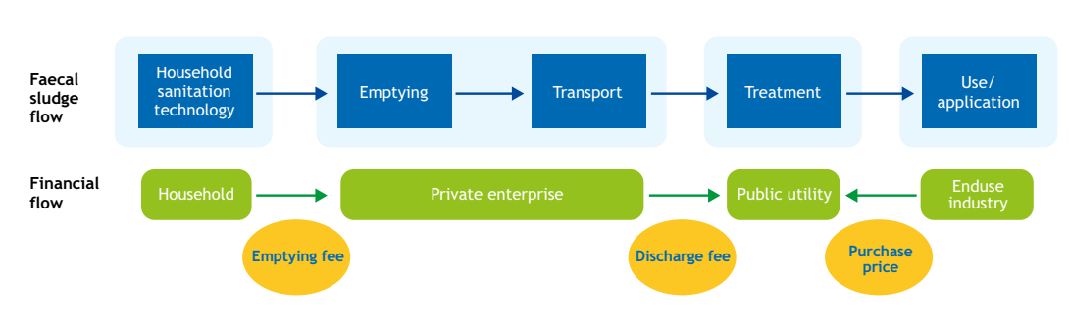

An alternate revenue model of this discrete collection and treatment model is used in Kerala, which seems to be profitable. In the model, households pay the emptying fee to the LSG and the LSG takes the treatment charge and pays the private operator with vehicle fee. The assigned emptier by LSG receives the vehicle fee from the LSG and empties the containment of the household. With the treatment charge the LSG provides the O&M charge to the private operator for operating and maintaining the FSTP. The Household will not be paying the emptier as the payment will be provided by the LSG and the FSTP operator can take the revenue from the sale of FSTP by-products like co-compost, manure or treated water with the consent of the LSG.

**Faecal & Financial flow of Modified Discrete Collection and treatment model**

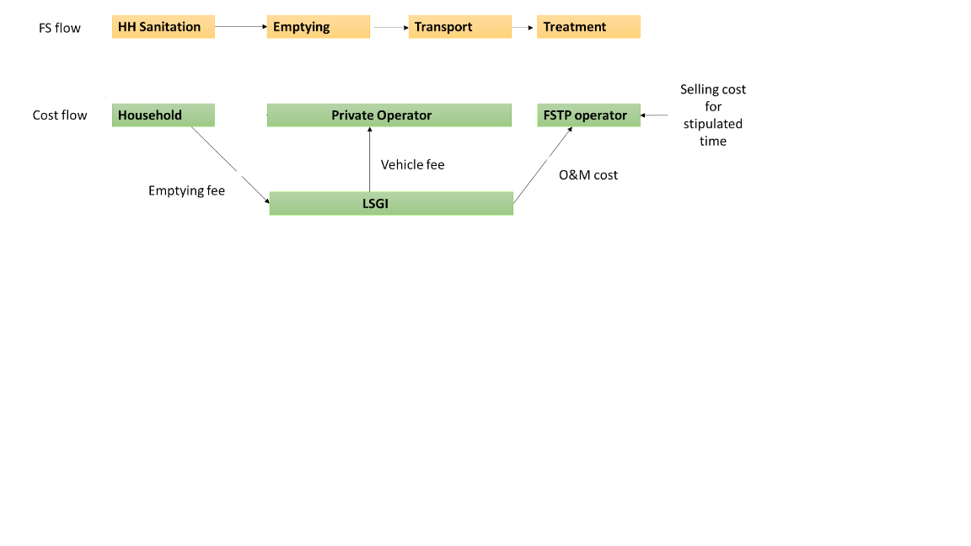

There are diverse financial models and the models can be customized based on the LSG. The models can be found in Faecal Sludge and Septage Management (FSSM) business model by NITI Aayog and National Faecal Sludge and Septage Management (NFSSM).

### 7. Funding for FSTP

The LSG is eligible to get 50% of FSTP capital cost in urban regions as per SBM (Urban) and greywater management facilities must be present in the LSG which adopt the FSTP. In rural areas, Rs.236 per capita living in the area and also, funding can be taken from 15th Central Finance Committee funds. Political representative funds or State government funds or corporate social responsibility funds may also be used for the establishment of FSTP in the state.